UNITED STATES

SECURITIES AND EXCHANGE COMMISSION
Washington, D.C. 20549

FORM 6-K

REPORT OF FOREIGN PRIVATE ISSUER PURSUANT TO RULE 13a-16 OR 15d-16 UNDER THE SECURITIES EXCHANGE ACT OF 1934

For the month of September, 2022.

Commission File Number: 001-40530

GH Research PLC

(Exact name of registrant as specified in its charter)

28 Baggot Street Lower

Dublin 2
D02 NX43
Ireland
(Address of principal executive office)

Indicate by check mark whether the registrant files or will file annual reports under cover of Form 20-F or Form 40-F:

Form 20-F ☒ Form 40-F ☐

Indicate by check mark if the registrant is submitting the Form 6-K in paper as permitted by Regulation S-T Rule 101(b)(1): ☐

Indicate by check mark if the registrant is submitting the Form 6-K in paper as permitted by Regulation S-T Rule 101(b)(7): ☐

On September 22, 2022, at the Interdisciplinary Conference on Psychedelic Research 2022, an investigator will present data related to a Phase 1/2 clinical trial of GH001 (GH001-TRD-102) conducted by GH Research PLC (the “Company”). A copy of the presentation is attached hereto as Exhibit 99.1.

Additionally, on September 23, 2022, an investigator will present data at a poster session related to a Phase 1 clinical trial of GH001 (GH001-HV-101) conducted by the Company. A copy of the poster is attached hereto as Exhibit 99.2.

The fact that these materials are being made available and furnished herewith should not be deemed an admission as to the materiality of any information contained in the materials. The information contained in these materials is being provided as of September 21, 2022 and the Company does not undertake any obligation to update these materials in the future or to update forward-looking statements to reflect subsequent actual results.

1

EXHIBIT INDEX

Exhibit No. |  | Description
99.1 |  | Presentation for September 2022
99.2 |  | Poster for September 2022

2

SIGNATURE

Pursuant to the requirements of the Securities Exchange Act of 1934, the registrant has duly caused this report to be signed on its behalf by the undersigned, thereunto duly authorized.

GH Research PLC
Date: September 21, 2022
By: | /s/ Julie Ryan
Name: | Julie Ryan
Title: | Vice President, Finance
3

Exhibit 99.1
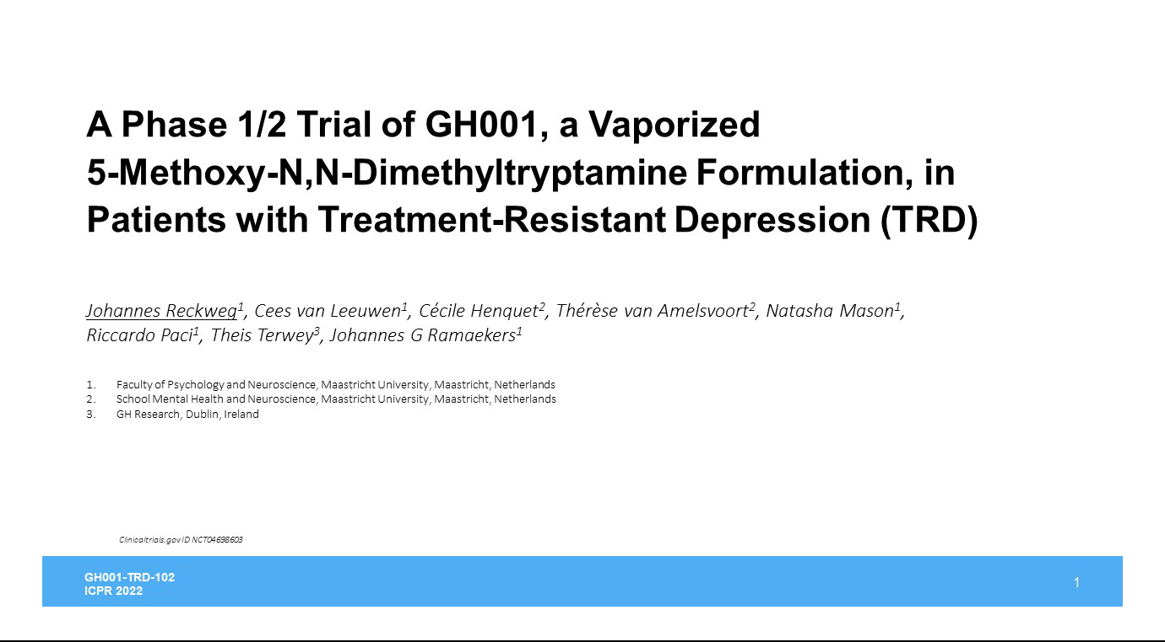

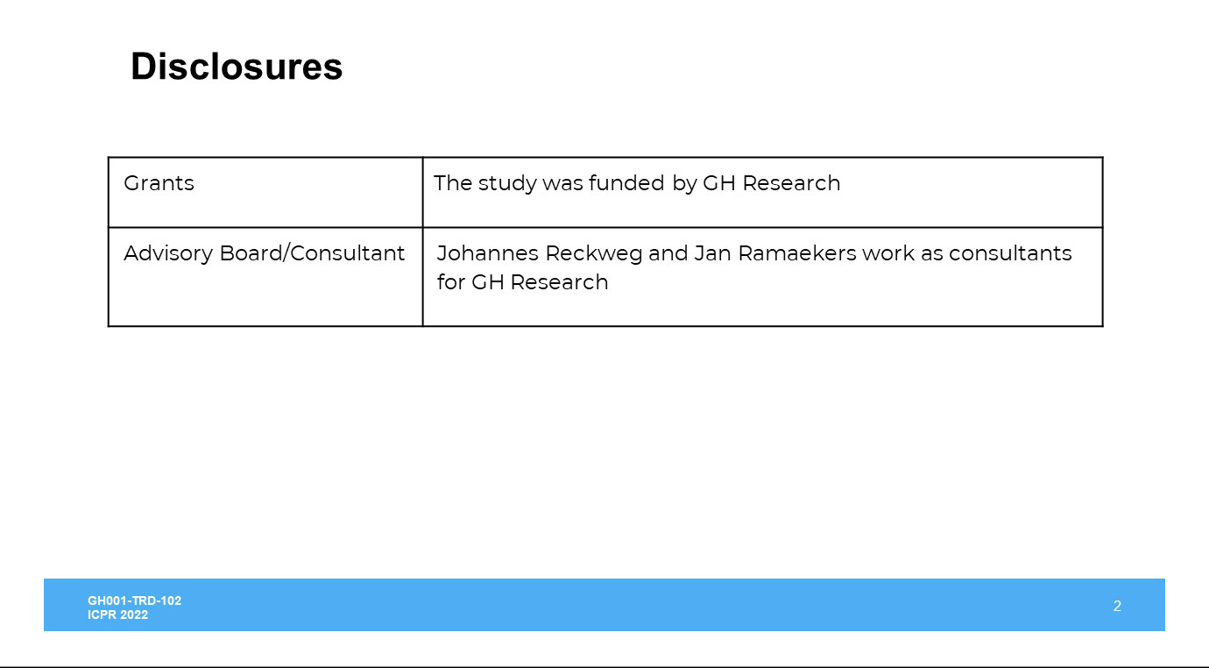

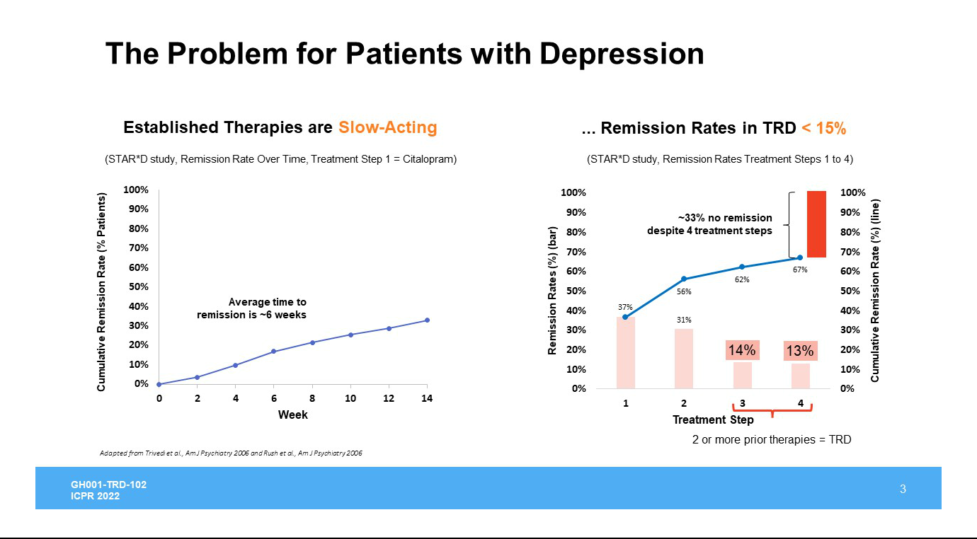

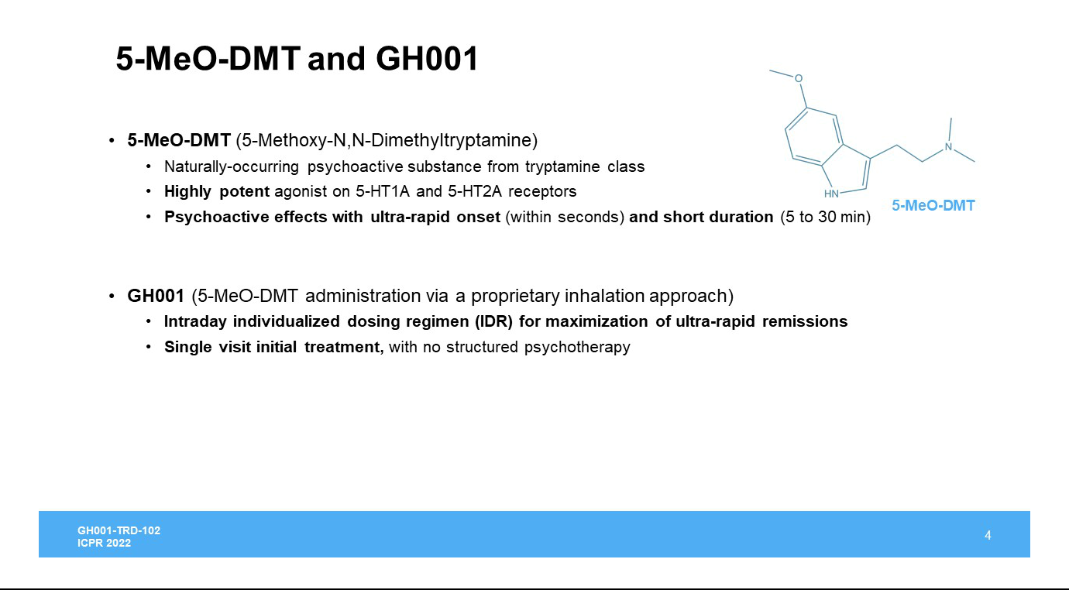

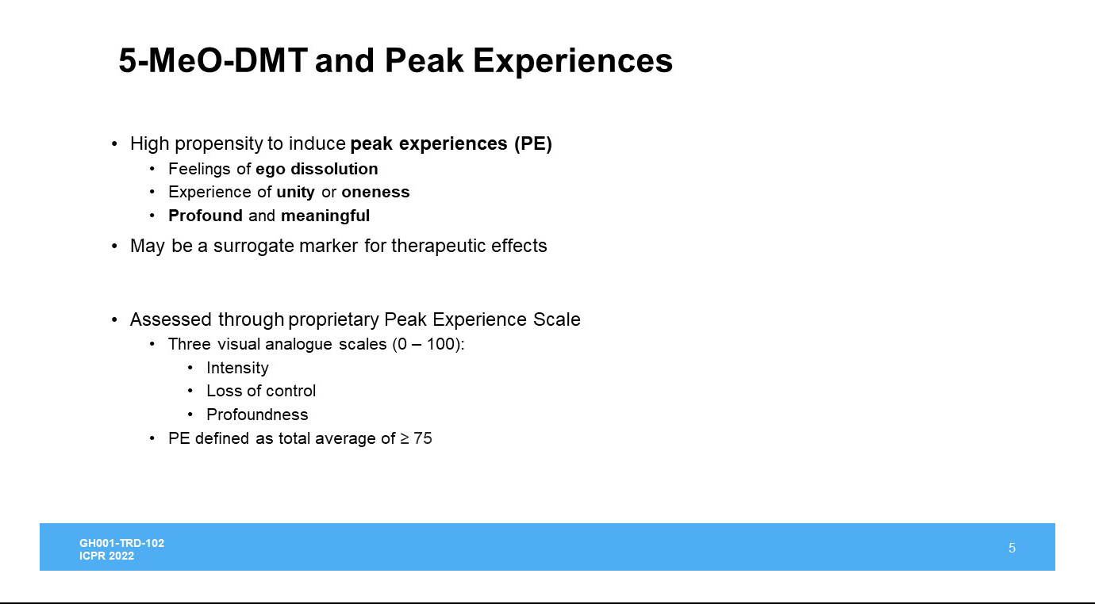

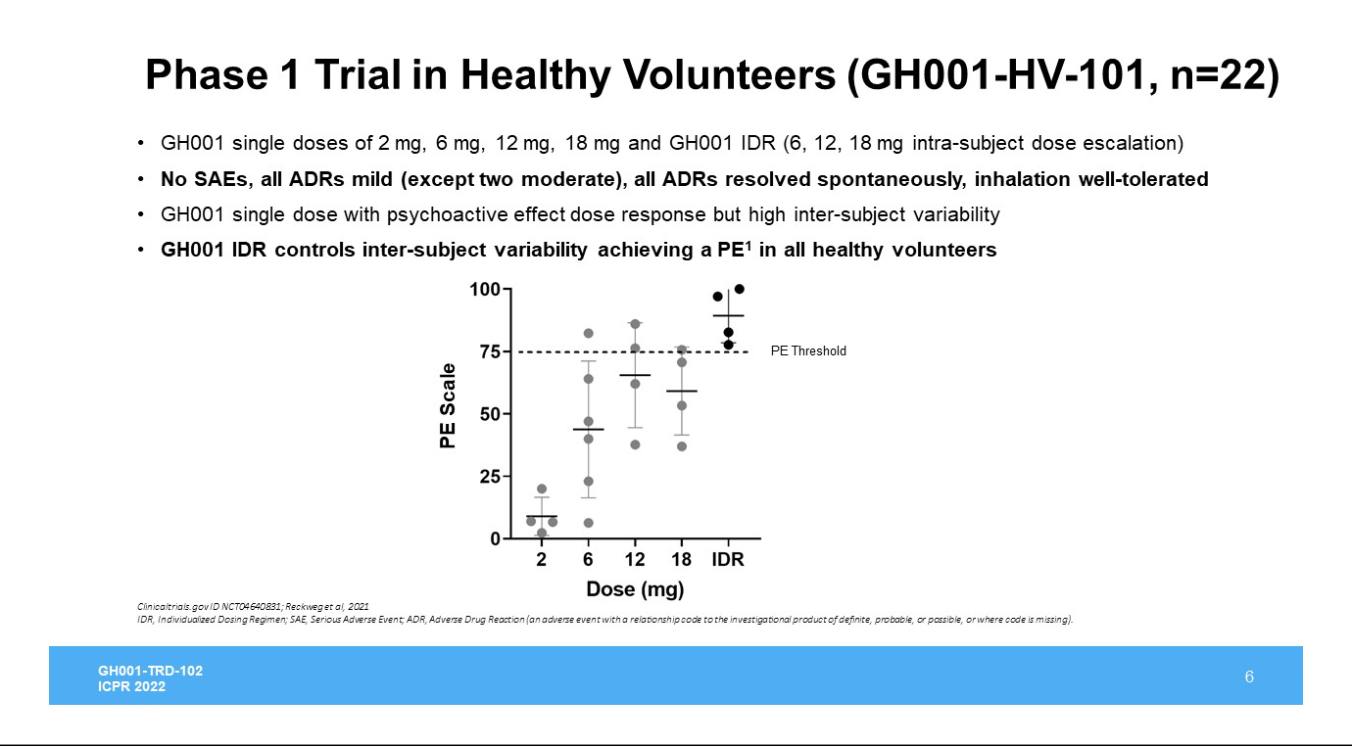

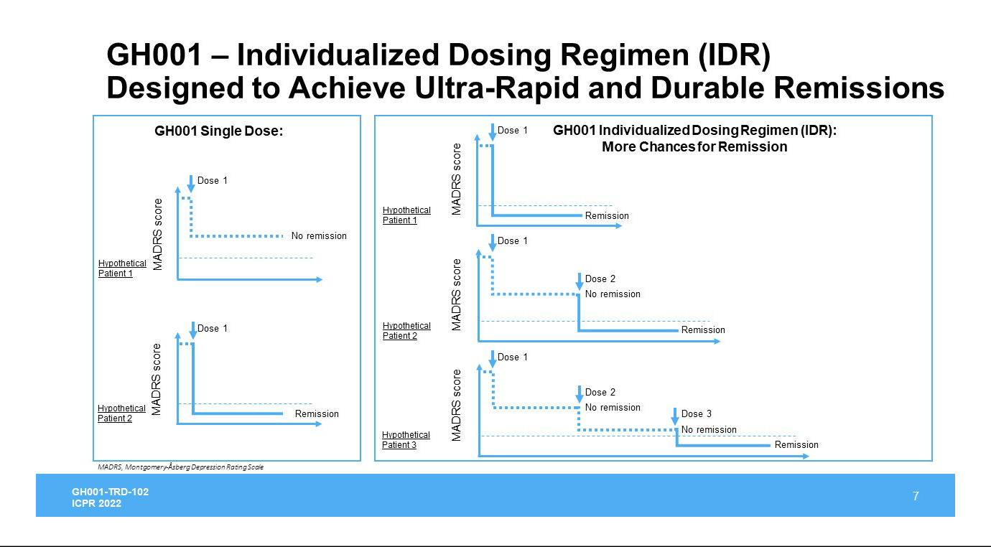

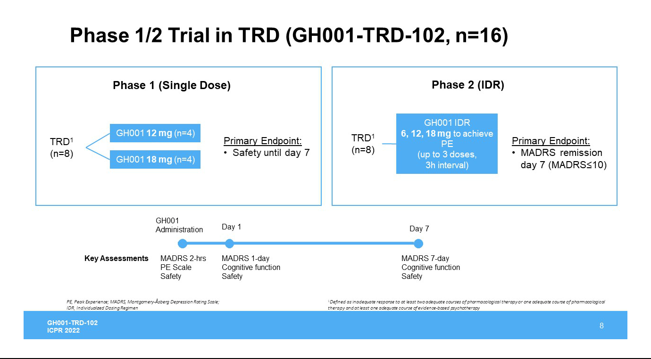

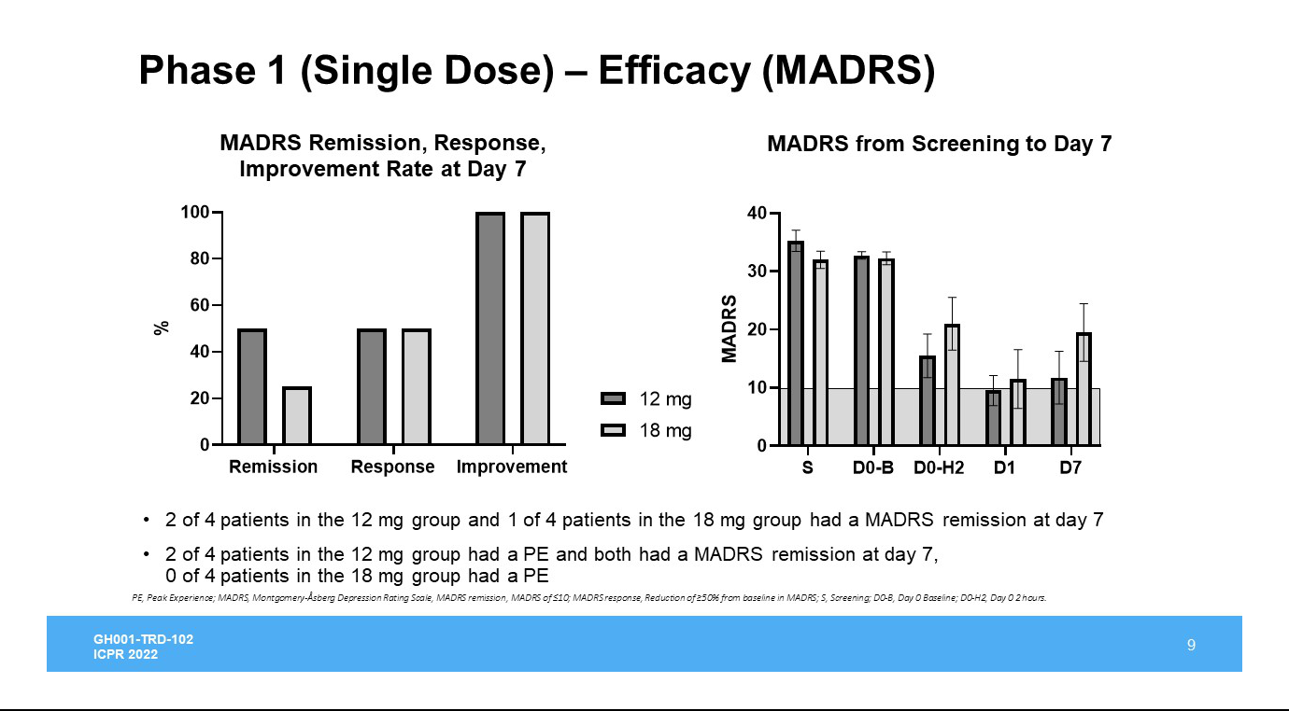

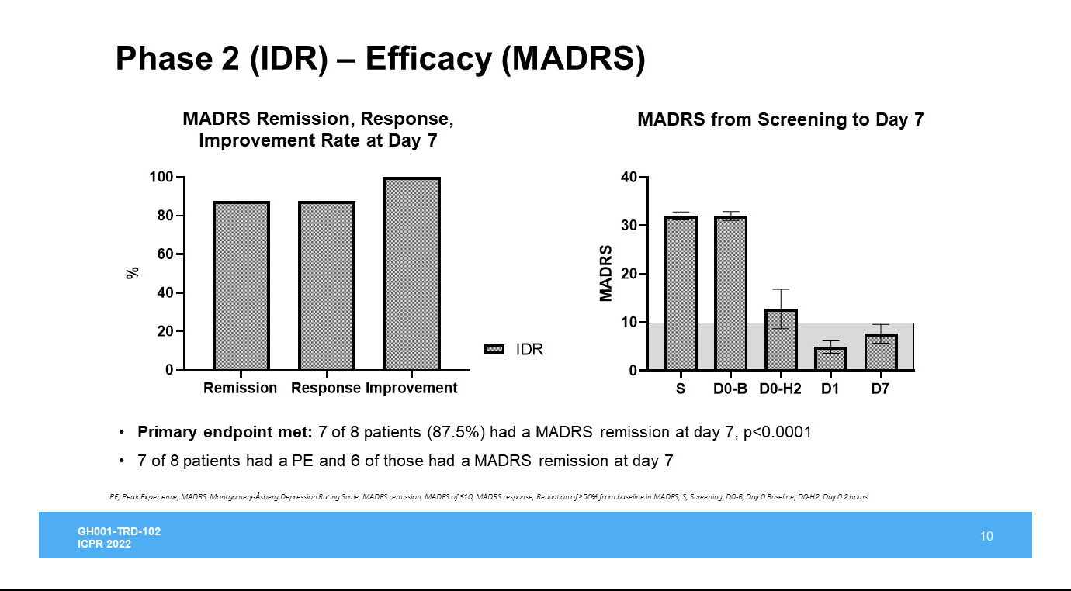

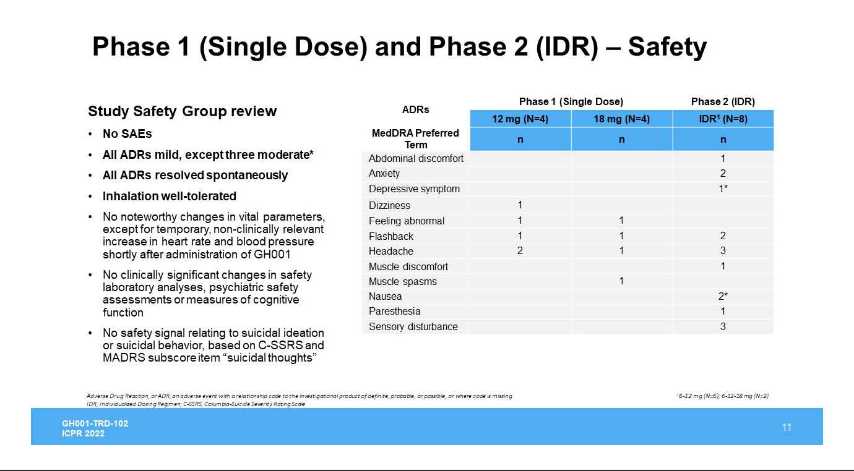

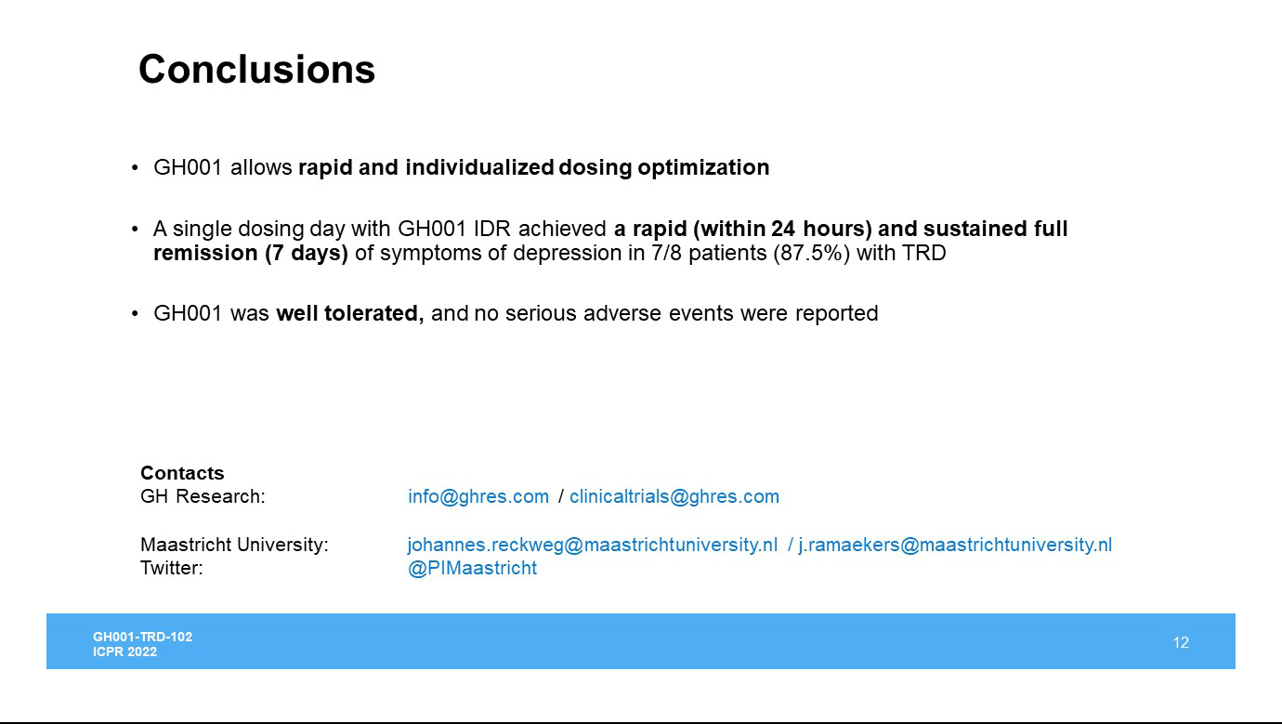

Exhibit 99.2


