UNITED STATES
SECURITIES AND EXCHANGE COMMISSION
Washington, D.C. 20549

FORM 6-K

REPORT OF FOREIGN PRIVATE ISSUER PURSUANT TO RULE 13a-16 OR 15d-16 UNDER THE SECURITIES EXCHANGE ACT OF 1934

For the month of August, 2026.

Commission File Number: 001-40530

GH Research PLC
(Exact name of registrant as specified in its charter)

Joshua Dawson House
Dawson Street
Dublin 2
D02 RY95
Ireland
(Address of principal executive office)

Indicate by check mark whether the registrant files or will file annual reports under cover of Form 20-F or Form 40-F:

 | Form 20-F | ☒ |  | Form 40-F

INFORMATION CONTAINED IN THIS REPORT ON FORM 6-K

On August 6, 2026, GH Research PLC (the “Company”) reported its second quarter 2026 financial results, provided business updates, and made available an updated corporate presentation on its website. A copy of the press release is exhibited hereto as Exhibit 99.3 and a copy of the corporate presentation is exhibited hereto as Exhibit 99.4.

The fact that this press release and the corporate presentation is being made available and furnished herewith should not be deemed an admission as to the materiality of any information contained in the materials. The information contained in the press release and corporate presentation is being provided as of August 6, 2026, and the Company does not undertake any obligation to update the press release or the presentation in the future or to update forward-looking statements to reflect subsequent actual results.

1

INCORPORATION BY REFERENCE

This Report on Form 6-K, (other than Exhibit 99.3 and Exhibit 99.4 hereto), including Exhibit 99.1 and Exhibit 99.2 hereto, shall be deemed to be incorporated by reference into the registration statement on Form S-8 (Registration Nos. 333-270422, 333-285311 and 333-294036) and the registration statement on Form F-3 (Registration Nos. 333-285310 and 333-295872) of the Company and to be a part thereof from the date on which this report is filed, to the extent not superseded by documents or reports subsequently filed or furnished

2

EXHIBIT INDEX

Exhibit No. | Description
99.1 | Unaudited Condensed Consolidated Interim Financial Statements for the three and six months ended June 30, 2026
99.2 | Management’s Discussion and Analysis of Financial Condition and Results of Operations
99.3 | Press release dated August 6, 2026
99.4 | Corporate Presentation for August 2026
101.INS | Inline XBRL Instance Document
101.SCH | Inline XBRL Taxonomy Extension Schema Document
101.CAL | Inline XBRL Taxonomy Extension Calculation Linkbase Document
101.DEF | Inline XBRL Taxonomy Extension Definition Linkbase Document
101.LAB | Inline XBRL Taxonomy Extension Label Linkbase Document
101.PRE | Inline XBRL Taxonomy Extension Presentation Linkbase Document
104 | Cover Page Interactive Data File (embedded within the Inline XBRL document)

3

SIGNATURE

Pursuant to the requirements of the Securities Exchange Act of 1934, the registrant has duly caused this report to be signed on its behalf by the undersigned, thereunto duly authorized.

 | GH Research PLC
Date: August 6, 2026
 | By: | /s/ Julie Ryan
 | Name: | Julie Ryan
 | Title: | Vice President, Finance

4

Exhibit 99.1


GH RESEARCH PLC

Unaudited condensed consolidated interim statement of comprehensive loss

 |  |  |  |  |  | Three months ended  June 30, |  |  |  |  |  |  |  | Six months ended  June 30,
 |  |  |  |  |  | 2026 |  |  |  | 2025 |  |  |  | 2026 |  |  |  | 2025
 |  | Note |  |  |  | $’000 |  |  |  | $’000 |  |  |  | $’000 |  |  |  | $’000
Operating expenses
Research and development |  | 3 |  |  |  |  | (12,399 | ) |  |  | (8,958 | ) |  |  | (24,778 | ) |  |  | (16,810 | )
General and administration |  | 3 |  |  |  |  | (7,056 | ) |  |  | (5,746 | ) |  |  | (13,426 | ) |  |  | (10,626 | )
Loss from operations |  |  |  |  |  |  | (19,455 | ) |  |  | (14,704 | ) |  |  | (38,204 | ) |  |  | (27,436 | )
Finance income |  | 4 |  |  |  |  | 2,657 |  |  |  | 3,074 |  |  |  | 4,851 |  |  |  | 5,833
Finance expense |  | 4 |  |  |  |  | (83 | ) |  |  | (174 | ) |  |  | (167 | ) |  |  | (352 | )
Movement of expected credit loss |  |  |  |  |  |  | 7 |  |  |  | 13 |  |  |  | 8 |  |  |  | (6 | )
Foreign exchange gain/(loss) |  |  |  |  |  |  | 1,728 |  |  |  | 2,502 |  |  |  | (601 | ) |  |  | 1,860
Total other income |  |  |  |  |  |  | 4,309 |  |  |  | 5,415 |  |  |  | 4,091 |  |  |  | 7,335
Loss before tax |  |  |  |  |  |  | (15,146 | ) |  |  | (9,289 | ) |  |  | (34,113 | ) |  |  | (20,101 | )
Tax charge/(credit) |  |  |  |  |  |  | - |  |  |  | - |  |  |  | - |  |  |  | -
Loss for the period |  |  |  |  |  |  | (15,146 | ) |  |  | (9,289 | ) |  |  | (34,113 | ) |  |  | (20,101 | )
Other comprehensive (expense)/income
Items that may be reclassified to profit or loss
Fair value movement on marketable securities |  |  |  |  |  |  | (45 | ) |  |  | (82 | ) |  |  | (129 | ) |  |  | (22 | )
Currency translation adjustment |  |  |  |  |  |  | (2,561 | ) |  |  | 457 |  |  |  | (1,739 | ) |  |  | 989
Total comprehensive loss for the period |  |  |  |  |  |  | (17,752 | ) |  |  | (8,914 | ) |  |  | (35,981 | ) |  |  | (19,134 | )
Attributable to owners:
Loss for the period |  |  |  |  |  |  | (15,146 | ) |  |  | (9,289 | ) |  |  | (34,113 | ) |  |  | (20,101 | )
Total comprehensive loss for the period |  |  |  |  |  |  | (17,752 | ) |  |  | (8,914 | ) |  |  | (35,981 | ) |  |  | (19,134 | )
Loss per share
Basic and diluted loss per share (in USD) |  | 15 |  |  |  |  | (0.23 | ) |  |  | (0.15 | ) |  |  | (0.53 | ) |  |  | (0.33 | )

The accompanying notes are an integral part of these unaudited condensed consolidated interim financial statements. | 1

GH RESEARCH PLC

Unaudited condensed consolidated interim statement of financial position

 |  |  |  |  |  |  | At June 30, |  |  |  | At December 31,
 |  |  |  |  |  |  | 2026 |  |  |  | 2025
 |  |  | Note |  |  |  | $’000 |  |  |  | $’000
ASSETS
Current assets
Cash and cash equivalents |  |  | 5 |  |  |  |  | 345,053 |  |  |  | 246,251
Marketable securities |  |  | 6 |  |  |  |  | 17,597 |  |  |  | 34,457
Other current assets |  |  | 7 |  |  |  |  | 6,174 |  |  |  | 5,268
Total current assets |  |  |  |  |  |  |  | 368,824 |  |  |  | 285,976
Non-current assets
Property, plant and equipment |  |  |  |  |  |  |  | 502 |  |  |  | 620
Other non-current assets |  |  | 8 |  |  |  |  | 3,023 |  |  |  | 1,634
Total non-current assets |  |  |  |  |  |  |  | 3,525 |  |  |  | 2,254
Total assets |  |  |  |  |  |  |  | 372,349 |  |  |  | 288,230
LIABILITIES AND EQUITY
Current liabilities
Trade payables |  |  | 9 |  |  |  |  | 5,933 |  |  |  | 3,773
Lease liability |  |  |  |  |  |  |  | 354 |  |  |  | 365
Other current liabilities |  |  | 10 |  |  |  |  | 6,566 |  |  |  | 4,242
Total current liabilities |  |  |  |  |  |  |  | 12,853 |  |  |  | 8,380
Non-current liabilities
Lease liability |  |  |  |  |  |  |  | 6 |  |  |  | 147
Total non-current liabilities |  |  |  |  |  |  |  | 6 |  |  |  | 147
Total liabilities |  |  |  |  |  |  |  | 12,859 |  |  |  | 8,527
Equity attributable to owners
Share capital |  |  |  |  |  |  |  | 1,716 |  |  |  | 1,551
Additional paid-in capital |  |  |  |  |  |  |  | 542,672 |  |  |  | 431,061
Other reserves |  |  |  |  |  |  |  | 16,453 |  |  |  | 13,292
Foreign currency translation reserve |  |  |  |  |  |  |  | (13,515 | ) |  |  | (11,776 | )
Accumulated deficit |  |  |  |  |  |  |  | (187,836 | ) |  |  | (154,425 | )
Total equity |  |  |  |  |  |  |  | 359,490 |  |  |  | 279,703
Total liabilities and equity |  |  |  |  |  |  |  | 372,349 |  |  |  | 288,230

The accompanying notes are an integral part of these unaudited condensed consolidated interim financial statements. | 2

GH RESEARCH PLC

Unaudited condensed consolidated interim statement of changes in equity

 |  | Attributable to owners
 |  | Share capital |  |  |  | Additional  paid-in  capital |  |  |  | Other  reserves |  |  |  | Foreign  currency  translation  reserve |  |  |  | Accumulated  deficit |  |  |  | Total
 |  | $’000 |  |  |  | $’000 |  |  |  | $’000 |  |  |  | $’000 |  |  |  | $’000 |  |  |  | $’000
At January 1, 2025 |  |  | 1,301 |  |  |  | 291,463 |  |  |  | 5,194 |  |  |  | (12,561 | ) |  |  | (106,446 | ) |  |  | 178,951
Loss for the period |  |  | - |  |  |  | - |  |  |  | - |  |  |  | - |  |  |  | (20,101 | ) |  |  | (20,101 | )
Other comprehensive (expense)/income |  |  | - |  |  |  | - |  |  |  | (22 | ) |  |  | 989 |  |  |  | - |  |  |  | 967
Total comprehensive loss for the period |  |  | - |  |  |  | - |  |  |  | (22 | ) |  |  | 989 |  |  |  | (20,101 | ) |  |  | (19,134 | )
Share-based compensation expense |  |  | - |  |  |  | - |  |  |  | 3,514 |  |  |  | - |  |  |  | - |  |  |  | 3,514
Transfer of share options |  |  | - |  |  |  | - |  |  |  | (269 | ) |  |  | - |  |  |  | 269 |  |  |  | -
Share option exercises |  |  | - |  |  |  | - |  |  |  | (10 | ) |  |  | - |  |  |  | 10 |  |  |  | -
Issue of share capital |  |  | 250 |  |  |  | 139,598 |  |  |  | - |  |  |  | - |  |  |  | - |  |  |  | 139,848
Total transactions with owners |  |  | 250 |  |  |  | 139,598 |  |  |  | 3,235 |  |  |  | - |  |  |  | 279 |  |  |  | 143,362
At June 30, 2025 |  |  | 1,551 |  |  |  | 431,061 |  |  |  | 8,407 |  |  |  | (11,572 | ) |  |  | (126,268 | ) |  |  | 303,179
At January 1, 2026 |  |  | 1,551 |  |  |  | 431,061 |  |  |  | 13,292 |  |  |  | (11,776 | ) |  |  | (154,425 | ) |  |  | 279,703
Loss for the period |  |  | - |  |  |  | - |  |  |  | - |  |  |  | - |  |  |  | (34,113 | ) |  |  | (34,113 | )
Other comprehensive expense |  |  | - |  |  |  | - |  |  |  | (129 | ) |  |  | (1,739 | ) |  |  | - |  |  |  | (1,868 | )
Total comprehensive loss for the period |  |  | - |  |  |  | - |  |  |  | (129 | ) |  |  | (1,739 | ) |  |  | (34,113 | ) |  |  | (35,981 | )
Share-based compensation expense |  |  | - |  |  |  | - |  |  |  | 3,992 |  |  |  | - |  |  |  | - |  |  |  | 3,992
Transfer of share options |  |  | - |  |  |  | - |  |  |  | (702 | ) |  |  | - |  |  |  | 702 |  |  |  | -
Share option exercises |  |  | 2 |  |  |  | 537 |  |  |  | - |  |  |  | - |  |  |  | - |  |  |  | 539
Issue of share capital |  |  | 163 |  |  |  | 111,074 |  |  |  | - |  |  |  | - |  |  |  | - |  |  |  | 111,237
Total transactions with owners |  |  | 165 |  |  |  | 111,611 |  |  |  | 3,290 |  |  |  | - |  |  |  | 702 |  |  |  | 115,768
At June 30, 2026 |  |  | 1,716 |  |  |  | 542,672 |  |  |  | 16,453 |  |  |  | (13,515 | ) |  |  | (187,836 | ) |  |  | 359,490

The accompanying notes are an integral part of these unaudited condensed consolidated interim financial statements. | 3

GH RESEARCH PLC

Unaudited condensed consolidated interim statement of cash flows

Six months ended
June 30,
 |  | 2026 |  |  |  | 2025
 |  | $’000 |  |  |  | $’000
Cash flows from operating activities
Loss for the period |  |  | (34,113 | ) |  |  | (20,101 | )
Depreciation |  |  | 182 |  |  |  | 158
Share-based compensation expense |  |  | 3,992 |  |  |  | 3,514
Finance income |  |  | (4,851 | ) |  |  | (5,833 | )
Finance expense |  |  | 167 |  |  |  | 352
Movement of expected credit loss |  |  | (8 | ) |  |  | 6
Foreign exchange loss/(gain) |  |  | 601 |  |  |  | (1,860 | )
Movement in working capital |  |  | 2,116 |  |  |  | 1,369
Cash flows used in operating activities |  |  | (31,914 | ) |  |  | (22,395 | )
Finance expense paid |  |  | (87 | ) |  |  | (360 | )
Finance income received |  |  | 6,310 |  |  |  | 5,215
Net cash used in operating activities |  |  | (25,691 | ) |  |  | (17,540 | )
Cash flows from investing activities
Purchase of property, plant and equipment |  |  | (80 | ) |  |  | (63 | )
Proceeds from sale of other financial assets |  |  | - |  |  |  | 19,585
Proceeds from redemptions and disposals of marketable securities |  |  | 15,061 |  |  |  | 8,026
Cash flows from investing activities |  |  | 14,981 |  |  |  | 27,548
Cash flows from financing activities
Proceeds from share issuances |  |  | 118,039 |  |  |  | 150,000
Transaction costs from share issuances |  |  | (6,028 | ) |  |  | (10,152 | )
Payment of lease liability |  |  | (141 | ) |  |  | (63 | )
Net cash flows from financing activities |  |  | 111,870 |  |  |  | 139,785
Net increase in cash and cash equivalents |  |  | 101,160 |  |  |  | 149,793
Cash and cash equivalents at the beginning of the period |  |  | 246,251 |  |  |  | 100,791
Impact of foreign exchange on cash and cash equivalents |  |  | (2,358 | ) |  |  | 3,289
Cash and cash equivalents at the end of the period |  |  | 345,053 |  |  |  | 253,873

The accompanying notes are an integral part of these unaudited condensed consolidated interim financial statements. | 4

GH RESEARCH PLC
NOTES TO THE UNAUDITED CONDENSED CONSOLIDATED INTERIM FINANCIAL STATEMENTS

1. | Corporate information

GH Research PLC (the “Company”) was incorporated on March 29, 2021. The registered office of the Company is located at Joshua Dawson House, Dawson Street, Dublin 2, Ireland. The Company and its subsidiary, GH Research Ireland Limited, form the GH Research Group (the “Group” or “GH Research”).

The Company is a clinical-stage biopharmaceutical company dedicated to transforming the lives of patients by developing a practice-changing treatment in depression. Its initial focus is on developing the novel and proprietary mebufotenin therapies for the treatment of patients with Treatment Resistant Depression, or TRD. Its portfolio currently includes GH001, a proprietary inhalable mebufotenin product candidate and GH002, a proprietary intravenous mebufotenin product candidate.

In April 2026, the Group completed an underwritten offering of its ordinary shares. The net proceeds of the offering were estimated to be $111.2 million, after deducting underwriting discounts and directly attributable transaction costs.

These unaudited condensed consolidated interim financial statements were presented to the board of directors and approved by them for issue on August 6, 2026.

2. | Basis of preparation, significant judgments, and accounting policies

Basis of preparation

Compliance with IFRS Accounting Standards
The unaudited condensed consolidated interim financial statements for the three and six months ended June 30, 2026, have been prepared in accordance with IAS 34 “Interim Financial Reporting”. The unaudited condensed consolidated interim financial statements do not include all of the information required for full annual financial statements and should be read in conjunction with the consolidated financial statements for the year ended December 31, 2025, which were prepared in accordance with IFRS Accounting Standards as adopted by the International Accounting Standards Board (“IASB”). These unaudited condensed consolidated interim financial statements are presented in U.S. dollar (“USD” or “$”), which is the Company’s functional currency and the Group’s presentation currency.

The financial information presented in this interim report does not represent full statutory accounts as defined by the Companies Act 2014. The statutory accounts of the Company for the year ended December 31, 2025, are expected to be filed with the Companies Registration Office by November 26, 2026.

New and amended IFRS standards
There are no new IFRS Accounting standards, amendments to standards or interpretations that are mandatory for the financial year beginning on January 1, 2026, that are relevant to the Group and that have had any material impact in the interim period. The review of the impact of new standards on the Group’s financial statements, which are not yet effective and which have not been early adopted by the Group is ongoing. This includes IFRS 18 “Presentation and Disclosure in Financial Statements”. IFRS 18 will replace IAS 1 “Presentation of financial statements”, introducing new requirements that will help to achieve comparability of the financial performance of similar entities and provide more relevant information and transparency to users. Management is currently assessing the detailed implications of applying the new standard on the Group’s financial statements.

Going concern basis
GH Research is a clinical-stage biopharmaceutical company developing innovative therapeutics. The Group is exposed to all risks inherent in establishing and developing its business, including the substantial uncertainty that current projects will succeed. Research and development expenses have been incurred from the start of the Group’s activities, generating negative cash flows from operating activities since formation.

Since its incorporation, the Group has funded its growth through capital increases. The Group has no bank loans or other debt outstanding, except lease liabilities, as of June 30, 2026. As a result, the Group is not exposed to liquidity risk through requests for early repayment of loans.

5

GH RESEARCH PLC
NOTES TO THE UNAUDITED CONDENSED CONSOLIDATED INTERIM FINANCIAL STATEMENTS (continued)
As of June 30, 2026, the Group’s cash and cash equivalents amounted to $345.1 million (December 31, 2025: $246.3 million). The Group also held marketable securities of $17.6 million as of June 30, 2026, (December 31, 2025: marketable securities of $34.5 million). The marketable securities held by the Group are quoted in active markets and are an additional source of liquidity.

The Board of Directors believes that the Group has sufficient financial resources available to cover its planned cash outflows for at least the next twelve months from the date of issuance of these unaudited condensed consolidated interim financial statements. The Group, therefore, continues to adopt the going concern basis in preparing its unaudited condensed consolidated interim financial statements.

Use of estimates and judgments
The preparation of the unaudited condensed consolidated interim financial statements requires management to make judgments, estimates and assumptions that affect the application of accounting policies and the reported amounts of assets and liabilities, income and expense. Actual results may differ from these estimates.

In preparing these unaudited condensed consolidated interim financial statements, the significant judgments made by management in applying the Group’s accounting policies and the key sources of estimation uncertainty are consistent with those that applied in the preparation of the consolidated financial statements for the year ended December 31, 2025.

Accounting policies
The accounting policies, presentation and methods of computation followed in the unaudited condensed consolidated interim financial statements are consistent with those applied in the Group’s most recent annual financial statements and have been applied consistently to all periods presented in the unaudited condensed consolidated interim financial statements.

Current and deferred income tax
The interim income tax expense is calculated based on the Company’s estimate of the weighted average effective annual income tax rate expected for the full year. The current and deferred income tax charge was $nil for the three and six months ended June 30, 2026 and 2025, which is in line with the Company’s estimate for the full year. No deferred tax assets have been recognized as there is no certainty that sufficient taxable profits will be generated within the required timeframe to be able to utilize these tax loss carry-forwards in full.

Segment reporting
Management considers the Group to have only a single segment: Research and Development (“R&D”). This is consistent with the way that information is reported internally within the Group for the purpose of allocating resources and assessing performance.

6

GH RESEARCH PLC
NOTES TO THE UNAUDITED CONDENSED CONSOLIDATED INTERIM FINANCIAL STATEMENTS (continued)
3. | Expenses by nature

The following table provides the consolidated statement of comprehensive loss classification of our expense by nature:

 |  | Three months ended  June 30, |  |  |  |  |  |  |  | Six months ended  June 30,
 |  | 2026 |  |  |  | 2025 |  |  |  | 2026 |  |  |  | 2025
 |  | $’000 |  |  |  | $’000 |  |  |  | $’000 |  |  |  | $’000
External research and development expenses1 |  |  | 8,241 |  |  |  | 6,101 |  |  |  | 16,786 |  |  |  | 11,568
Employee expenses2, 5 |  |  | 4,158 |  |  |  | 2,857 |  |  |  | 7,992 |  |  |  | 5,242
Total research and development expenses3 |  |  | 12,399 |  |  |  | 8,958 |  |  |  | 24,778 |  |  |  | 16,810
External costs1 |  |  | 4,976 |  |  |  | 3,769 |  |  |  | 9,240 |  |  |  | 6,708
Employee expenses4, 5 |  |  | 2,080 |  |  |  | 1,977 |  |  |  | 4,186 |  |  |  | 3,918
Total general and administrative expenses3 |  |  | 7,056 |  |  |  | 5,746 |  |  |  | 13,426 |  |  |  | 10,626
Total operating expenses |  |  | 19,455 |  |  |  | 14,704 |  |  |  | 38,204 |  |  |  | 27,436

1 Includes depreciation expense.

2 Included in employee expenses is share-based compensation expense of $1.3 million and $2.2 million for the three and six months ended June 30, 2026, respectively, relating to employees in the research and development department (three and six months ended June 30, 2025, expense of $0.8 million and $1.5 million, respectively).

3 Depreciation and other expenses have been reclassified to external research and development expenses and depreciation has been reclassified to external costs for all periods presented as it provides more relevant information.

4 Included in employee expenses is share-based compensation expense of $0.9 million and $1.8 million for the three and six months ended June 30, 2026, respectively, relating to employees in the general and administrative department (three and six months ended June 30, 2025, expense of $1.0 million and $2.0 million, respectively).

5 Includes termination expenses incurred.

Foreign exchange gain/loss

Foreign exchange gain of $1.7 million for the three months ended June 30, 2026 (gain of $2.5 million for the three months ended June 30, 2025), and foreign exchange loss of $0.6 million for the six months ended June 30, 2026 (gain of $1.9 million for the six months ended June 30, 2025) consists primarily of gains and losses related to the translation of the Group’s assets and liabilities from their denominated currencies into the functional currency of each entity, and included the strengthening of the U.S. dollar in the period.

7

GH RESEARCH PLC
NOTES TO THE UNAUDITED CONDENSED CONSOLIDATED INTERIM FINANCIAL STATEMENTS (continued)
4. | Finance income and expense

 |  | Three months ended  June 30, |  |  |  |  |  |  |  | Six months ended  June 30,
 |  | 2026 |  |  |  | 2025 |  |  |  | 2026 |  |  |  | 2025
 |  | $’000 |  |  |  | $’000 |  |  |  | $’000 |  |  |  | $’000
Finance income
Finance income on cash, cash equivalents and other financial assets |  |  | 808 |  |  |  | 596 |  |  |  | 1,140 |  |  |  | 1,888
Gain on cash equivalents and other financial assets at fair value through profit and loss (“FVTPL”) |  |  | 1,608 |  |  |  | 1,819 |  |  |  | 3,136 |  |  |  | 2,564
Interest income under effective interest rate method at fair value through other comprehensive income (“FVOCI”) |  |  | 241 |  |  |  | 659 |  |  |  | 575 |  |  |  | 1,381
Finance income |  |  | 2,657 |  |  |  | 3,074 |  |  |  | 4,851 |  |  |  | 5,833
Finance expense
Finance expense on investments |  |  | (77 | ) |  |  | (165 | ) |  |  | (155 | ) |  |  | (333 | )
Finance expense on lease liability |  |  | (6 | ) |  |  | (9 | ) |  |  | (12 | ) |  |  | (19 | )
Finance expense |  |  | (83 | ) |  |  | (174 | ) |  |  | (167 | ) |  |  | (352 | )

5. | Cash and cash equivalents

 |  | June 30, |  |  |  | December 31,
 |  | 2026 |  |  |  | 2025
 |  | $’000 |  |  |  | $’000
Cash at bank and in hand |  |  | 37,454 |  |  |  | 30,972
Cash equivalents |  |  | 307,599 |  |  |  | 215,279
 |  |  | 345,053 |  |  |  | 246,251

During the six months ended June 30, 2026, proceeds of $17.1 million were received from the redemption of marketable securities, which includes accrued interest. On redemption of the marketable securities, the funds are invested in cash equivalents.

8

GH RESEARCH PLC
NOTES TO THE UNAUDITED CONDENSED CONSOLIDATED INTERIM FINANCIAL STATEMENTS (continued)

6. | Marketable securities

Marketable
securities
 |  | $’000
Fair value
At January 1, 2026 |  |  | 34,457
Accrued interest |  |  | 575
Interest received |  |  | (214 | )
Redemptions and disposals of marketable securities |  |  | (17,100 | )
Revaluation adjustment |  |  | (121 | )
At June 30, 2026 |  |  | 17,597

At June 30, 2026, the Group’s marketable securities mature within the next year.

The movement through other comprehensive income, (“OCI”), for the three and six months ended June 30, 2026, and June 30, 2025, is shown in the table below:

 |  | Three months ended  June 30, |  |  |  |  |  |  |  | Six months ended  June 30,
 |  | 2026 |  |  |  | 2025 |  |  |  | 2026 |  |  |  | 2025
 |  | $’000 |  |  |  | $’000 |  |  |  | $’000 |  |  |  | $’000
Revaluation adjustments |  |  | (38 | ) |  |  | (69 | ) |  |  | (121 | ) |  |  | (28 | )
Movement of expected credit losses on assets measured at FVOCI |  |  | (7 | ) |  |  | (13 | ) |  |  | (8 | ) |  |  | 6
Movement on marketable securities through OCI |  |  | (45 | ) |  |  | (82 | ) |  |  | (129 | ) |  |  | (22 | )

7. | Other current assets

Other current assets primarily represent prepayments and research and development tax credit receivable.

8. | Other non-current assets

Other non-current assets represent research and development tax credit receivable.

9. | Trade payables

Trade payables primarily represent amounts incurred for the provision of manufacturing, research and consulting services and professional fees, which are outstanding at the end of the period. Trade payables are due to be settled at different times within 12 months.

10. | Other current liabilities

Other current liabilities primarily represent accruals for operating expenses and employee tax payable and are expected to be settled within one year.

9

GH RESEARCH PLC
NOTES TO THE UNAUDITED CONDENSED CONSOLIDATED INTERIM FINANCIAL STATEMENTS (continued)
11. | Share capital

Number of
outstanding
shares
At December 31, 2025 |  |  | 62,029,395
Share issue from offering |  |  | 6,527,779
Share option exercise1 |  |  | 85,113
At June 30, 2026 |  |  | 68,642,287

1 See Note 13

In April 2026, the Group completed an underwritten offering of its ordinary shares in which it issued and sold an aggregate of 6,527,779 ordinary shares at a price of $18.00 per share. The estimated net proceeds of the underwritten offering were $111.2 million, after deducting underwriting discounts and estimated directly attributable transaction costs.
12. | Contingencies

As of June 30, 2026, there were no material contingencies which required adjustment or disclosure in the unaudited condensed consolidated interim financial statements (2025: none).

13. | Share based compensation

Share Options
In June 2021, the Company adopted a share option plan referred to herein as the Share Option Plan under which grants of options are made to eligible participants. The Company initially reserved 1,202,734 ordinary shares for future issuance under the Share Option Plan, which includes ordinary shares pursuant to share-based equity awards issued to date. As of June 30, 2026, the total number of ordinary shares which may be issued under the Share Option Plan was 3,721,251 and the Company has 925,853 ordinary shares available for the future issuance of share-based equity awards.

Under the Share Option Plan, the options may be settled only in ordinary shares of the Company. Therefore, the grants of share options under the Share Option Plan have been accounted for as equity-settled under IFRS 2. As such, the Company records a charge for the vested portion of award grants and for partially earned but non-vested portions of award grants.

During the three and six months ended June 30, 2026, the Company granted the option to purchase 17,100 and 219,050 ordinary shares which were in line with the general terms of the Share Option Plan. Of the share options granted in the three and six months ended June 30, 2026, 17,100 and 69,600 share options, respectively, were granted which vest 25% on the first anniversary of the date of the grant, and thereafter evenly on a monthly basis over the subsequent three years and are subject to a two-year service condition. The contractual term (expiration) of these share options is eight years from the grant date with an exercise price of the closing market price on the day prior to the grant. Of the share options granted in the six months ended June 30, 2026, 149,450 share options were granted which vest 25% on the first anniversary of the date of grant, and thereafter evenly on a monthly basis over the subsequent three years. The contractual term (expiration) of these share options is seven years from the grant date with an exercise price of $0.025.

10

GH RESEARCH PLC
NOTES TO THE UNAUDITED CONDENSED CONSOLIDATED INTERIM FINANCIAL STATEMENTS (continued)

The following table summarizes the share option awards outstanding as of June 30, 2026:

 |  | Average exercise  price per share  in  USD |  |  |  | Number of  awards |  |  |  | Weighted  average  remaining  life  in years
At December 31, 2025 |  |  | 3.87 |  |  |  | 2,594,914 |  |  |  | 5.91
Granted |  |  | 5.23 |  |  |  | 219,050 |  |  |  | 6.93
Forfeited/Expired |  |  | 7.11 |  |  |  | (27,112 | ) |  |  | 5.11
Exercised1 |  |  | 6.33 |  |  |  | (85,113 | ) |  |  | 5.03
At June 30, 20262 |  |  | 3.87 |  |  |  | 2,701,739 |  |  |  | 5.56

1 The weighted average share price of share options exercised was $19.36.
2 998,920 of the awards outstanding as of June 30, 2026, were exercisable.

The weighted average grant date fair value of awards granted during the three and six months ended June 30, 2026, was $15.51 and $13.34 per award, respectively.

The fair values of the options granted were determined on the date of the grant using the Black-Scholes option-pricing model. The fair values of the options granted during the three and six months ended June 30, 2026, were determined on the date of the grant using the following assumptions:

 |  | Three months ended  June 30, 2026 |  |  |  | Six months ended  June 30, 2026
Share price, in USD |  |  | 14.72 - 24.87 |  |  |  | 13.03 - 24.87
Strike price, in USD (weighted average) |  |  | 21.11 |  |  |  | 5.23
Expected volatility |  |  | 82% - 83% |  |  |  | 82% - 88%
Award life (weighted average) |  |  | 6.0 |  |  |  | 5.7
Expected dividends |  |  | - |  |  |  | -
Risk-free interest rate |  |  | 4.06% - 4.24% |  |  |  | 3.79% - 4.24%

The expected volatility for the three months ended June 30, 2026, is based on a blended rate of historical volatility observed among other comparable public companies and the Company’s own historical volatility.

The award life is based on the time interval between the date of grant and the date during the life of the share option after which, when making the grant, the Company expected on average that participants would exercise their options.

As of June 30, 2026, Other Reserves within equity includes $16.4 million (December 31, 2025: $13.1 million) relating to the Group’s Share Option Plan. Balances which relate to forfeited awards which had previously vested or awards which have been exercised are transferred from Other Reserves to Accumulated Deficit. The amount of expense for all awards recognized for services received during the three months ended June 30, 2026, was $2.2 million (three months ended June 30, 2025: expense of $1.9 million) and for the six months ended June 30, 2026, was an expense of $4.0 million (six months ended June 30, 2025: expense of $3.5 million).

14. | Related party disclosures

There have been no transactions in the three months ended June 30, 2026, (2025: none) with related parties that had a material effect on the financial position or performance of the Group.

11

GH RESEARCH PLC
NOTES TO THE UNAUDITED CONDENSED CONSOLIDATED INTERIM FINANCIAL STATEMENTS (continued)
15. | Loss per share

 |  | Three months ended  June 30, |  |  |  |  |  |  |  | Six months ended  June 30,
 |  | 2026 |  |  |  | 2025 |  |  |  | 2026 |  |  |  | 2025
Loss attributable to shareholders (in $’000) |  |  | (15,146 | ) |  |  | (9,289 | ) |  |  | (34,113 | ) |  |  | (20,101 | )
Weighted average number of shares in issue |  |  | 66,534,362 |  |  |  | 62,028,736 |  |  |  | 64,296,628 |  |  |  | 60,039,492
Basic and diluted loss per share (in USD) |  |  | (0.23 | ) |  |  | (0.15 | ) |  |  | (0.53 | ) |  |  | (0.33 | )

For the three months and the six months ended June 30, 2026, and 2025, basic and diluted loss per share are calculated on the weighted average number of shares issued and outstanding and exclude shares to be issued under the Share Option Plan, as the effect of including those shares would be anti-dilutive.

16. | Events after the reporting date

There were no events after the reporting date requiring disclosure in the Group’s unaudited condensed consolidated interim financial statements.

12

Exhibit 99.2

MANAGEMENT’S DISCUSSION AND ANALYSIS OF FINANCIAL CONDITION AND RESULTS OF OPERATIONS

This management’s discussion and analysis is designed to provide you with a narrative explanation of our financial condition and results of operations. You should read this discussion and analysis in conjunction with our unaudited condensed consolidated interim financial statements, including the notes thereto, as of and for the three and six months ended June 30, 2026. You should also read this discussion and analysis in conjunction with our audited consolidated financial statements, including the notes thereto, and the section in our annual report on Form 20-F for the year ended December 31, 2025 titled “Item 3. Key Information—D. Risk Factors.”

Our unaudited condensed consolidated interim financial statements for the three and six months ended June 30, 2026, were prepared in accordance with International Accounting Standard 34, Interim Financial Reporting. The terms “dollar,” “USD” or “$” refer to U.S. dollars. We have made rounding adjustments to some of the figures included in this discussion. Accordingly, any numerical discrepancies in any table between totals and sums of the amounts listed are due to rounding.

Unless otherwise indicated or the context otherwise requires, all references in this discussion and analysis to “GH Research” or “GH,” the “Company,” “we,” “our,” “ours,” “us” or similar terms refer to GH Research PLC and its consolidated subsidiary.

Overview

We are a clinical-stage biopharmaceutical company dedicated to transforming the lives of patients by developing a practice-changing treatment in depression. Our initial focus is on developing our novel and proprietary mebufotenin therapies for the treatment of patients with treatment-resistant depression, or TRD.

Our portfolio currently includes GH001, our proprietary inhalable mebufotenin product candidate, and GH002, our proprietary intravenous mebufotenin product candidate. While GH001 is currently delivered via a vaporization device produced by a third party, we are developing a proprietary aerosol delivery device, which is currently in clinical investigation in Europe. We have completed two Phase 1 healthy volunteer clinical trials for GH001 (GH001-HV-101 and GH001-HV-103), in which administration of GH001 via inhalation was observed to be well tolerated at the investigated single dose levels and in an individualized dosing regimen, or IDR, with intra-subject dose escalation within a single day. We have also completed a Phase 1/2 clinical trial in patients with TRD (GH001-TRD-102) and a multi-center randomized, double-blind, placebo-controlled Phase 2b trial with an Open-Label Extension of GH001 in patients with TRD (GH001-TRD-201). Based on observed clinical activity in these clinical trials, we believe that administration of GH001 has the potential to induce ultra-rapid remissions as measured by the Montgomery–Åsberg Depression Rating Scale, or MADRS, in TRD patients.

We have incurred losses since inception, including losses of $34.1 million for the six months ended June 30, 2026, and losses of $48.3 million and $39.0 million for the years ended December 31, 2025 and 2024, respectively. As of June 30, 2026, we had an accumulated deficit of $187.8 million. We expect to incur significant expenses and operating losses for the foreseeable future as we expand our research and development activities. In addition, our losses from operations may fluctuate significantly from quarter-to-quarter and year-to-year, depending on the timing of our clinical trials, our expenditures on other research and development activities and based on foreign currency translation differences. We anticipate that our expenses will increase significantly in connection with our ongoing activities, if and as we:

 | • | continue to develop and conduct clinical trials, including in expanded geographies such as the United States, for our GH001 and GH002 product candidates for our initial indications and any additional indications;

 | • | continue both the technical development and expansion of our external manufacturing capabilities for our current product candidates GH001 and GH002, and of the medical devices required to deliver these product candidates, such as our proprietary aerosol delivery device for GH001;

 | • | initiate and continue research and development, including technical, nonclinical, clinical, and discovery efforts for any future product candidates;

 | • | seek to identify additional product candidates;

 | • | seek regulatory approvals for our product candidates GH001 and GH002 including the medical devices required to deliver these product candidates, such as our proprietary aerosol delivery device for GH001, or any other product candidates that successfully complete clinical development;

 | • | add operational, financial and management information systems and personnel, including personnel to support our product candidate and device development and help us comply with our obligations as a public company;

 | • | hire and retain additional personnel, such as clinical, quality control, scientific, commercial, sales, marketing and administrative personnel;

 | • | continue to prepare, file, prosecute, maintain, protect and enforce our intellectual property rights and claims;

 | • | establish sales, marketing, distribution, manufacturing, supply chain and other commercial infrastructure in the future to commercialize various products for which we may obtain regulatory approval;

 | • | comply with ongoing regulatory requirements for products approved for commercial sale, if ever;

 | • | adapt to ongoing changes in global economic conditions, including but not limited to continuing inflation, imposition of tariffs and trade barriers, interest rates and foreign currency exchange rates, disruptions in global supply chains and labor markets and geopolitical risks and global hostilities, including any direct or indirect economic impacts resulting from conflicts in Eastern Europe and the Middle East, tariff and trade wars, or increased tensions between China and Taiwan;

 | • | acquire or in-license other product candidates, medical devices to deliver our product candidates, and other technologies; and

 | • | incur increased costs as a result of operating as a public company.

In addition, as we progress toward marketing approval for any of our product candidates, we also expect to incur significant commercialization expenses related to product manufacturing, marketing, sales, and distribution. As a result, we will need substantial additional funding to support our continuing operations and pursue our growth strategy. Until such time as we can generate significant revenue from product sales, if ever, we expect to finance our operations through the sale of equity, debt financings or other capital sources, including potential collaborations with other companies or other strategic transactions. We cannot be certain that additional funding will be available on acceptable terms, or at all. If we fail to raise capital or enter into such agreements as, and when needed, we may have to significantly delay, scale back, or discontinue the development and commercialization of one or more of our product candidates or other research and development initiatives, which could have a material adverse effect on our business, results of operations, and financial condition. We will need to generate significant revenue to achieve profitability, and we may never do so.

We are subject to a number of risks comparable to those of other similar companies, including dependence on key individuals; the need to develop product candidates with the required safety and efficacy profile and which support regulatory approval and are commercially viable; competition from other companies, many of which are larger and better capitalized; and the need to obtain adequate additional financing to fund the development of our product candidates.

Business Updates

Global Pivotal Program of GH001 in TRD

We have completed GH001-HV-106, our Phase 1 clinical pharmacology trial of our proprietary aerosol delivery device in healthy volunteers, and GH001-HV-109, our IND-opening Phase 1 trial of GH001 in healthy volunteers in the United States. Based on the results of GH001-HV-106, we have selected the doses for our pivotal program.

In July 2026, we received written responses from the FDA confirming that our CMC and device plans appear Phase 3 ready. We continue to engage with the FDA on the design of the pivotal program, which is intended to replicate the Phase 2b trial, including consideration of recent FDA guidance issued in July 2026, and we continue to target initiation of our pivotal program in 2026.

Intellectual Property

In July 2026, the U.S. Patent and Trademark Office granted U.S. Patent No. 12,685,721, with claims directed to methods of treating major depressive disorder (MDD) and treatment-resistant depression (TRD), by administering an aerosol of mebufotenin, which is expected to expire no earlier than 2043.

Also in July 2026, the main request of our European Patent No. 3 927 337 was maintained following an opposition hearing before the European Patent Office. As maintained, the patent claims mebufotenin, and salts thereof, for use in the treatment of MDD and TRD including, but not limited to, mebufotenin administered through inhalation, intravenous and intranasal routes, and is expected to expire no earlier than 2040.

Publications and Scientific Presentations

In June 2026, the full results of our Phase 2a trial of GH001 in postpartum depression were published in The Journal of Clinical Psychiatry. In addition, an analysis of our Phase 2b GH001-TRD-201 trial showing efficacy independent of the number of prior antidepressant treatment failures was published in Psychopharmacology Bulletin. Data from GH001-TRD-201 were also presented at the American Society of Clinical Psychopharmacology Annual Meeting in May 2026 and at the 37th World Congress of Neuropsychopharmacology in June 2026, and further posters have been accepted for the International Society for Bipolar Disorders Annual Conference in September 2026 and the European College of Neuropsychopharmacology Congress in October 2026, where we will also host an industry symposium.

Results of Operations

Comparison of the Three months ended June 30, 2026 and 2025

The following table summarizes our results of operations for the three months ended June 30, 2026 and 2025:

​ |  | Three months ended  June 30
​ |  | 2026 |  |  |  | 2025 |  |  |  | Change
 |  | (in USD thousands)
Operating Expenses:
Research and development |  |  | (12,399 | ) |  |  | (8,958 | ) |  |  | (3,441 | )
General and administrative |  |  | (7,056 | ) |  |  | (5,746 | ) |  |  | (1,310 | )
Loss from operations |  |  | (19,455 | ) |  |  | (14,704 | ) |  |  | (4,751 | )
Net finance income1 |  |  | 2,581 |  |  |  | 2,913 |  |  |  | (332 | )
Foreign exchange gain |  |  | 1,728 |  |  |  | 2,502 |  |  |  | (774 | )
Loss for the period |  |  | (15,146 | ) |  |  | (9,289 | ) |  |  | (5,857 | )

1 | Net finance income for the three months ended June 30, 2026 and 2025, comprises finance income, finance expense and expected credit losses.

Research and Development Expenses

The following table summarizes our research and development expenses for the three months ended June 30, 2026 and 2025:

​ |  | Three months ended  June 30
​ |  | 2026 |  |  |  | 2025 |  |  |  | Change
 |  | (in USD thousands)
External research and development expenses1 |  |  | (8,241 | ) |  |  | (6,101 | ) |  |  | (2,140 | )
Employee expenses2 |  |  | (4,158 | ) |  |  | (2,857 | ) |  |  | (1,301 | )
Research and development |  |  | (12,399 | ) |  |  | (8,958 | ) |  |  | (3,441 | )

1 | Includes depreciation expense.

2 | Includes a share-based compensation expense of $1.3 million and $0.8 million for the three months ended June 30, 2026 and 2025, respectively.

The following table summarizes our research and development expenses for our product candidates for the three months ended June 30, 2026 and 2025:

​ |  | Three months ended  June 30
​ |  | 2026 |  |  |  | 2025 |  |  |  | Change
 |  | (in USD thousands)
GH001 |  |  | (8,435 | ) |  |  | (5,897 | ) |  |  | (2,538 | )
GH002 |  |  | (154 | ) |  |  | (400 | ) |  |  | 246
Related to multiple product candidates and exploratory work for potential future product candidates |  |  | (3,810 | ) |  |  | (2,661 | ) |  |  | (1,149 | )
Research and development |  |  | (12,399 | ) |  |  | (8,958 | ) |  |  | (3,441 | )

Research and development expenses increased by $3.4 million to $12.4 million for the three months ended June 30, 2026, from $9.0 million for the three months ended June 30, 2025. The increase is primarily due to increased clinical development expenses, including clinical trial expenses; as well as employee expenses. These increases have been partly offset by an increase in the benefit of a research and development tax credit.

Research and development expenses for our product candidates will fluctuate from period to period primarily due to the nature and timing associated with the various lifecycle stages of each candidate.

Research and development expenses relating to GH001 increased by $2.5 million in the three months ended June 30, 2026, primarily due to an increase in our clinical development expenses, including clinical trial expenses.

Research and development expenses relating to GH002 decreased by $0.2 million in the three months ended June 30, 2026, primarily due to a decrease in nonclinical expenses.

Research and development expenses relating to multiple product candidates increased by $1.1 million in the three months ended June 30, 2026, primarily due to an increase in nonclinical expenses as well as employee expenses. These increases have been partly offset by an increase in the benefit of a research and development tax credit.

General and Administrative Expenses

The following table summarizes our general and administrative expenses for the three months ended June 30, 2026 and 2025:

Three months ended
June 30
 |  | 2026 |  |  |  | 2025 |  |  |  | Change
 |  | (in USD thousands)
External costs1 |  |  | (4,976 | ) |  |  | (3,769 | ) |  |  | (1,207 | )
Employee expenses2 |  |  | (2,080 | ) |  |  | (1,977 | ) |  |  | (103 | )
General and administrative |  |  | (7,056 | ) |  |  | (5,746 | ) |  |  | (1,310 | )

1 | Includes depreciation expense.

2 | Includes a share-based compensation expense of $0.9 million and $1.0 million for the three months ended June 30, 2026 and 2025, respectively.

General and administrative expenses increased by $1.3 million to $7.1 million for the three months ended June 30, 2026, from $5.7 million for the three months ended June 30, 2025. The increase is primarily due to an increase in professional fees.

Net Finance Income

Net finance income decreased by $0.3 million to $2.6 million for the three months ended June 30, 2026, from $2.9 million for the three months ended June 30, 2025. The decrease is primarily due to a decrease in finance income relating to return on investments.

Foreign Exchange Gain

Foreign exchange gain is $1.7 million for the three months ended June 30, 2026, a movement of $0.8 million from a gain of $2.5 million for the three months ended June 30, 2025. This movement is primarily as a result of the translation of our assets and liabilities from their denominated currencies into the functional currency of each entity.

Comparison of the Six months ended June 30, 2026 and 2025

The following table summarizes our results of operations for the six months ended June 30, 2026 and 2025:

​ |  | Six months ended  June 30
​ |  | 2026 |  |  |  | 2025 |  |  |  | Change
 |  | (in USD thousands)
Operating Expenses:
Research and development |  |  | (24,778 | ) |  |  | (16,810 | ) |  |  | (7,968 | )
General and administrative |  |  | (13,426 | ) |  |  | (10,626 | ) |  |  | (2,800 | )
Loss from operations |  |  | (38,204 | ) |  |  | (27,436 | ) |  |  | (10,768 | )
Net finance income1 |  |  | 4,692 |  |  |  | 5,475 |  |  |  | (783 | )
Foreign exchange (loss)/gain |  |  | (601 | ) |  |  | 1,860 |  |  |  | (2,461 | )
Loss for the period |  |  | (34,113 | ) |  |  | (20,101 | ) |  |  | (14,012 | )

1 | Net finance income for the six months ended June 30, 2026 and 2025, comprises finance income, finance expense and expected credit losses.

Research and Development Expenses

The following table summarizes our research and development expenses for the six months ended June 30, 2026 and 2025:

​ |  | Six months ended  June 30
​ |  | 2026 |  |  |  | 2025 |  |  |  | Change
 |  | (in USD thousands)
External research and development expenses1 |  |  | (16,786 | ) |  |  | (11,568 | ) |  |  | (5,218 | )
Employee expenses2 |  |  | (7,992 | ) |  |  | (5,242 | ) |  |  | (2,750 | )
Research and development |  |  | (24,778 | ) |  |  | (16,810 | ) |  |  | (7,968 | )

1 | Includes depreciation expense.

2 | Includes share-based compensation expense of $2.2 million and $1.5 million for the six months ended June 30, 2026 and 2025, respectively.

The following table summarizes our research and development expenses for our product candidates for the six months ended June 30, 2026 and 2025:

​ |  | Six months ended  June 30
​ |  | 2026 |  |  |  | 2025 |  |  |  | Change
 |  | (in USD thousands)
GH001 |  |  | (16,652 | ) |  |  | (10,837 | ) |  |  | (5,815 | )
GH002 |  |  | (393 | ) |  |  | (1,505 | ) |  |  | 1,112
Related to multiple product candidates and exploratory work for potential future product candidates |  |  | (7,733 | ) |  |  | (4,468 | ) |  |  | (3,265 | )
Research and development |  |  | (24,778 | ) |  |  | (16,810 | ) |  |  | (7,968 | )

Research and development expenses increased by $8.0 million to $24.8 million for the six months ended June 30, 2026, from $16.8 million for the six months ended June 30, 2025. The increase is primarily due to increased expenses relating to our technical development and clinical development expenses, including clinical trial expenses, as well as employee expenses. These increases have been partly offset by a decrease in nonclinical expenses.

Research and development expenses for our product candidates will fluctuate from period to period primarily due to the nature and timing associated with the various lifecycle stages of each candidate.

Research and development expenses relating to GH001 increased by $5.8 million in the six months ended June 30, 2026, primarily due to increased expenses relating to our technical development and clinical development expenses, including clinical trial expenses.

Research and development expenses relating to GH002 decreased by $1.1 million in the six months ended June 30, 2026, primarily due to a decrease in nonclinical expenses.

Research and development expenses relating to multiple product candidates increased by $3.3 million in the six months ended June 30, 2026, primarily due to an increase in nonclinical expenses as well as employee expenses.

General and Administrative Expenses

The following table summarizes our general and administrative expenses for the six months ended June 30, 2026, and 2025:

​ |  | Six months ended  June 30
​ |  | 2026 |  |  |  | 2025 |  |  |  | Change
 |  | (in USD thousands)
External costs1 |  |  | (9,240 | ) |  |  | (6,708 | ) |  |  | (2,532 | )
Employee expenses2 |  |  | (4,186 | ) |  |  | (3,918 | ) |  |  | (268 | )
General and administrative |  |  | (13,426 | ) |  |  | (10,626 | ) |  |  | (2,800 | )

1 | Includes depreciation expense.

2 | Includes share-based compensation expense of $1.8 million and $2.0 million for the six months ended June 30, 2026 and 2025, respectively.

General and administrative expenses increased by $2.8 million to $13.4 million for the six months ended June 30, 2026, from $10.6 million for the six months ended June 30, 2025. The increase is primarily due to an increase in professional fees.

Net Finance Income

Our net finance income decreased by $0.8 million to $4.7 million for the six months ended June 30, 2026, from $5.5 million for the six months ended June 30, 2025. The decrease is primarily due to a decrease in finance income relating to return on investments.

Foreign Exchange (Loss)/Gain

Foreign exchange loss is $0.6 million for the six months ended June 30, 2026, a movement of $2.5 million from a gain of $1.9 million for the six months ended June 30, 2025. This movement is primarily a result of the translation of our assets and liabilities from their denominated currencies into the functional currency of each entity.

Liquidity and Capital Resources

Sources of Liquidity

As of June 30, 2026, we had cash, cash equivalents and marketable securities of $362.7 million, compared to $280.7 million as of December 31, 2025. In April 2026, we completed an underwritten offering of ordinary shares and received net proceeds of $111.2 million, after deducting underwriting discounts and offering expenses. In May 2026, we established an at-the-market (ATM) offering program, pursuant to which we may offer and sell ordinary shares with an aggregate offering price of up to $200.0 million. There have been no shares sold under the ATM program to date. We plan to continue to fund our operating and capital funding needs through sales of additional equity or other forms of financing. We may also consider pursuing strategic partnerships for clinical development and commercialization of our product candidates. The sale of additional equity would result in dilution to our shareholders.

We have incurred operating losses since inception, and we have not generated any revenue from any product sales or any other sources. We have not yet commercialized any of our product candidates, which are in various phases of technical and clinical development, and we do not expect to generate revenue from sales of any products for several years, if at all. Until such time as we can generate significant revenue from product sales, if ever, we expect to finance our operations through the sale of equity, debt financings or other capital sources, including potential collaborations with other companies or other strategic transactions. We have funded our operations to date primarily through equity financings, including our initial public offering.

Cash Flows

The following table provides information regarding our cash flows for the six months ended June 30, 2026 and 2025:

​ |  | Six months ended  June 30
​ |  | 2026 |  |  |  | 2025 |  |  |  | Change
 |  | (in USD thousands)
Net cash flows used in operating activities |  |  | (25,691 | ) |  |  | (17,540 | ) |  |  | (8,151 | )
Net cash flows from investing activities |  |  | 14,981 |  |  |  | 27,548 |  |  |  | (12,567 | )
Net cash flows from financing activities |  |  | 111,870 |  |  |  | 139,785 |  |  |  | (27,915 | )
Net increase in cash and cash equivalents |  |  | 101,160 |  |  |  | 149,793 |  |  |  | (48,633 | )

Net Cash Flows Used in Operating Activities

Net cash flows used in operating activities increased by $8.2 million to $25.7 million for the six months ended June 30, 2026, from $17.5 million for the six months ended June 30, 2025, due to an increase in loss from operations for the period and movement in working capital.

Net Cash Flows From Investing Activities

Net cash flows from investing activities decreased by $12.6 million to $15.0 million for the six months ended June 30, 2026, from $27.5 million for the six months ended June 30, 2025, due to a decrease in the proceeds from the sale of other financial assets.

Net Cash Flows From Financing Activities

Net cash flows from financing activities decreased by $27.9 million to $111.9 million for the six months ended June 30, 2026, from $139.8 million for the six months ended June 30, 2025. The decrease is due to the difference in proceeds from the offerings completed in the respective periods.

Funding Requirements

We expect our expenses to continue to increase substantially in connection with our ongoing research and development activities, particularly as we advance the technical development work, nonclinical studies and clinical trials of our product candidates and the medical devices required to deliver such product candidates. In addition, if we obtain regulatory approval for any of our product candidates, we expect to incur significant commercialization expenses related to sales, marketing, manufacturing and distribution. Furthermore, we have incurred and expect to continue to incur additional costs associated with operating as a public company. Until such time, if ever, as we can generate substantial product revenues, we expect to finance our cash needs through a combination of public or private equity offerings, debt financings, convertible debt financings, strategic collaborations and licensing arrangements. If we are unable to raise additional funds through equity or debt financings when needed, we may be required to delay, limit, reduce or terminate our product development or future commercialization efforts or grant rights to develop and market product candidates that we would otherwise prefer to develop and market ourselves. Our future capital requirements will depend on many factors, which are outlined in our annual report on Form 20-F for the year ended December 31, 2025, and this discussion and analysis. We believe that we have sufficient financial resources available to cover our planned cash outflows for at least the next twelve months.

Critical Accounting Estimates

There have been no material changes to the significant accounting policies and significant judgments and estimates from those referred to in the section in our annual report on Form 20-F for the year ended December 31, 2025, titled “Item 5. Operating and Financial Review and Prospects—E. Critical Accounting Estimates.”

Emerging Growth Company Status

On April 5, 2012, the Jumpstart Our Business Startups Act of 2012 (“JOBS Act”) was enacted. As an emerging growth company, or EGC, we rely on exemptions and reduced reporting requirements under the JOBS Act including exemptions from (i) providing an auditor’s attestation report on our system of internal controls over financial reporting pursuant to Section 404(b) of the Sarbanes-Oxley Act and (ii) complying with any requirement that may be adopted by the Public Company Accounting Oversight Board, regarding mandatory audit firm rotation or a supplement to the auditor’s report providing additional information about the audit and the financial statements, known as the auditor discussion and analysis.

We will remain classified as an EGC until the earlier of (1) the last day of the fiscal year (i) in which we have total annual gross revenue of $1.235 billion; (ii) following the fifth anniversary of the completion of our initial public offering; or (iii) in which we are deemed to be a “large accelerated filer,” which requires the market value of our ordinary shares that is held by non-affiliates to exceed $700 million as of the prior June 30th, and (2) the date on which we have issued more than $1 billion in nonconvertible debt during the previous three-year period.

Recently Issued Accounting Pronouncements

As disclosed in note 2 to our unaudited condensed consolidated interim financial statements, there are no standards that are mandatory for the financial year beginning on January 1, 2026, that are relevant to, and have had any material impact on, our unaudited condensed consolidated interim financial statements. The review of the impact of new standards on our unaudited condensed consolidated interim financial statements, including IFRS 18 “Presentation and Disclosure in Financial Statements”, which is not yet effective, and which has not been early adopted by us, is ongoing.

Risk Factors

There have been no material changes in our risk factors since those reported in our Annual Report for the year ended December 31, 2025.

Cautionary Statement Regarding Forward-Looking Statements

This discussion contains statements that are, or may be deemed to be, forward-looking. All statements other than statements of historical fact included in this discussion, including statements regarding our future results of operations and financial position, business strategy, product candidates, medical devices required to deliver these product candidates, research pipeline, ongoing and currently planned preclinical studies and clinical trials, regulatory submissions and approvals, research and development costs, cash runway, timing and likelihood of success, as well as plans and objectives of management for future operations, are forward-looking statements. Many of the forward-looking statements contained in this discussion can be identified by the use of forward-looking words such as “may,” “anticipate,” “believe,” “could,” “expect,” “should,” “plan,” “intend,” “estimate,” “will,” “potential” and “ongoing,” among others.

Forward-looking statements appear in a number of places in this discussion and include, but are not limited to, statements regarding our intent, belief or current expectations. Forward-looking statements are based on our management’s beliefs and assumptions and on information currently available to our management. Such statements are subject to risks and uncertainties, and actual results may differ materially from those expressed or implied in the forward-looking statements due to various factors, including, but not limited to, those identified under the section titled “—Risk Factors” herein and the section in our annual report on Form 20-F for the year ended December 31, 2025, titled “Item 3. Key Information—D. Risk Factors.” These risks and uncertainties include, among others, factors relating to:

 | • | the commencement, timing, progress and results of our research and development programs, nonclinical studies and clinical trials;

 | • | the timing, progress and results of developing and conducting clinical trials for our GH001 and GH002 product candidates and the medical devices required to deliver these product candidates, such as our proprietary aerosol delivery device for GH001, for our initial and any additional indications;

 | • | our efforts to expand into other jurisdictions such as the United States and in Europe;

 | • | our expectations related to the technical development and expansion of our external manufacturing capabilities for our GH001 and GH002 product candidates as well as the medical devices required to deliver these product candidates, such as our proprietary aerosol delivery device for GH001;

 | • | our reliance on the success of our GH001 and GH002 product candidates;

 | • | the timing, scope or likelihood of regulatory filings and approvals by the FDA, the EMA, or other comparable foreign regulatory authorities, for our GH001 and GH002 product candidates and our initial and any additional indications;

 | • | our expectations regarding the size of the eligible patient populations for our GH001 and GH002 product candidates, if approved for commercial use;

 | • | our ability to identify third-party clinical trial sites to conduct trials and our ability to identify and train appropriately qualified therapists to administer our investigational therapy;

 | • | the effect of pandemics, such as the COVID-19 pandemic, epidemics, outbreaks of an infectious disease or similar events on aspects of our business or operations, including delays in the regulatory approval process, contracting with clinical trial sites and engaging in clinical trials;

 | • | our ability to implement our business model and our strategic plans for our business and GH001 and GH002 product candidates;

 | • | our ability to identify, develop or acquire and obtain approval by the FDA, EMA or other comparable foreign regulatory authorities of medical devices required to deliver our GH001 and GH002 product candidates, such as our proprietary aerosol delivery device for GH001;

 | • | our commercialization and marketing capabilities and strategy;

 | • | the effects of undesirable clinical trial outcomes and potential adverse public perception regarding the use of mebufotenin and psychedelics generally on the regulatory approval process and future development of our product;

 | • | the pricing, coverage and reimbursement of our GH001 and GH002 product candidates, if approved;

 | • | the scalability and commercial viability of our manufacturing methods and processes;

 | • | the rate and degree of market acceptance and clinical utility of our GH001 and GH002 product candidates;

 | • | our reliance on third-party suppliers for our nonclinical study and clinical trial drug substance and product candidate supplies, as well as key raw materials used in our manufacturing processes;

 | • | our ability to establish or maintain collaborations or strategic relationships or obtain additional funding;

 | • | our expectations regarding potential benefits of our GH001 and GH002 product candidates and our approach generally;

 | • | our expectations around regulatory development paths and with respect to Controlled Substances Act, or CSA, classification;

 | • | the scope of protection we and any current or future licensors or collaboration partners are able to establish and maintain for intellectual property rights covering our GH001 and GH002 product candidates;

 | • | our ability to operate our business without infringing, misappropriating, or otherwise violating the intellectual property rights and proprietary technology of third parties;

 | • | our ability to protect our intellectual property rights, including enforcing and defending intellectual property-related claims;

 | • | regulatory developments in the United States, under the laws and regulations of the European Union and other jurisdictions;

 | • | continuing inflation, imposition of tariffs and trade barriers, interest rates and foreign currency exchange rates, disruptions in global supply chains and labor markets, and geopolitical risks and global hostilities, including any direct or indirect economic impacts resulting from, conflict in Eastern Europe and the Middle East, tariff and trade wars, or increased tensions between China and Taiwan;

 | • | developments and projections relating to our competitors and our industry;

 | • | our ability to maintain an effective system of internal control over financial reporting;

 | • | the amount of time that our existing cash, cash equivalents and marketable securities will be sufficient to fund our operations and capital expenditures;

 | • | our estimates regarding expenses, capital requirements and needs for additional financing;

 | • | our ability to effectively manage our anticipated growth;

 | • | our ability to attract and retain qualified employees and key personnel;

 | • | whether we are classified as a passive foreign investment company for current and future periods;

 | • | our expectations regarding the time during which we will be an EGC under the JOBS Act or the time during which we will be a foreign private issuer;

 | • | the future trading price of the ordinary shares and impact of securities analysts’ reports on this price; and

 | • | other risks and uncertainties, including those listed under “—Risk Factors” herein and “Item 3. Key Information—D. Risk Factors” in our annual report on Form 20-F for the year ended December 31, 2025.

These forward-looking statements speak only as of the date of this discussion and are subject to a number of risks, uncertainties and assumptions described under the section titled “—Risk Factors” herein and the sections in our annual report on Form 20-F for the year ended December 31, 2025, titled “Item 3. Key Information—D. Risk Factors” and “Item 5. Operating and Financial Review and Prospects” and elsewhere in our annual report and this discussion. Because forward-looking statements are inherently subject to risks and uncertainties, some of which cannot be predicted or quantified and some of which are beyond our control, you should not rely on these forward-looking statements as predictions of future events. The events and circumstances reflected in our forward-looking statements may not be achieved or occur and actual results could differ materially from those projected in the forward-looking statements. Moreover, we operate in an evolving environment. New risk factors and uncertainties may emerge from time to time, and it is not possible for management to predict all risk factors and uncertainties. Except as required by applicable law, we do not plan to publicly update or revise any forward-looking statements contained herein, whether as a result of any new information, future events, changed circumstances or otherwise.

In addition, statements that “we believe” and similar statements reflect our beliefs and opinions on the relevant subject. These statements are based upon information available to us as of the date of this discussion, and while we believe such information forms a reasonable basis for such statements, such information may be limited or incomplete, and our statements should not be read to indicate that we have conducted an exhaustive inquiry into, or review of, all potentially available relevant information. These statements are inherently uncertain and investors are cautioned not to unduly rely upon these statements.

Exhibit 99.3



GH Research Reports Second Quarter 2026 Financial Results and Provides Business Update

 | • | Alignment with FDA on CMC and device plans for Phase 3

 | • | Successfully completed GH001-HV-106 and GH001-HV-109 Phase 1 trials

 | • | Further strengthening of US and EU mebufotenin patent estate

 | • | Phase 2a results in postpartum depression published in The Journal of Clinical Psychiatry

 | • | Cash, cash equivalents and marketable securities of $362.7 million as of June 30, 2026

DUBLIN, August 6, 2026 (GLOBE NEWSWIRE) -- GH Research PLC (Nasdaq: GHRS), a clinical-stage biopharmaceutical company dedicated to transforming the lives of patients by developing a practice-changing treatment in depression, today reported financial results for the quarter ended June 30, 2026, and provided a business update.

Business Updates

Global Pivotal Program of GH001 in TRD

We have completed GH001-HV-106, our Phase 1 clinical pharmacology trial of our proprietary aerosol delivery device in healthy volunteers, and GH001-HV-109, our IND-opening Phase 1 trial of GH001 in healthy volunteers in the United States. Based on the results of GH001-HV-106, we have selected the doses for our pivotal program.

In July 2026, we received written responses from the FDA confirming that our CMC and device plans appear Phase 3 ready. We continue to engage with the FDA on the design of the pivotal program, which is intended to replicate the Phase 2b trial, including consideration of recent FDA guidance issued in July 2026, and we continue to target initiation of our pivotal program in 2026.

Intellectual Property

In July 2026, the U.S. Patent and Trademark Office granted U.S. Patent No. 12,685,721, with claims directed to methods of treating major depressive disorder (MDD) and treatment-resistant depression (TRD), by administering an aerosol of mebufotenin, which is expected to expire no earlier than 2043. We continue to be the company with the earliest patent filings relating to treatment of MDD and TRD using mebufotenin and continue prosecution of further claims.

Also in July 2026, the main request of our European Patent No. 3 927 337 was maintained following an opposition hearing before the European Patent Office. As maintained, the patent claims mebufotenin, and salts thereof, for use in the treatment of MDD and TRD including, but not limited to, mebufotenin administered through inhalation, intravenous and intranasal routes, and is expected to expire no earlier than 2040.

Publications and Scientific Presentations

In June 2026, the full results of our Phase 2a trial of GH001 in postpartum depression were published in The Journal of Clinical Psychiatry. In addition, an analysis of our Phase 2b GH001-TRD-201 trial showing efficacy independent of the number of prior antidepressant treatment failures was published in Psychopharmacology Bulletin. Data from GH001-TRD-201 were also presented at the American Society of Clinical Psychopharmacology Annual Meeting in May 2026 and at the 37th World Congress of Neuropsychopharmacology in June 2026, and further posters have been accepted for the International Society for Bipolar Disorders Annual Conference in September 2026 and the European College of Neuropsychopharmacology Congress in October 2026, where we will also host an industry symposium.

Second Quarter 2026 Financial Highlights

Cash position

Cash, cash equivalents and marketable securities were $362.7 million as of June 30, 2026, compared to $280.7 million as of December 31, 2025. Gross proceeds from the underwritten offering in Q2 2026 were $117.5 million. Marketable securities are comprised of investment grade bonds.

Research and development expenses

R&D expenses were $12.4 million for the quarter ended June 30, 2026, compared to $9.0 million for the same quarter in 2025. The increase is primarily due to increased clinical development expenses as well as employee expenses.

General and administrative expenses

G&A expenses were $7.1 million for the quarter ended June 30, 2026, compared to $5.7 million for the same quarter in 2025. The increase is primarily due to an increase in professional fees.

Net loss

Net loss was $15.1 million, or $0.23 loss per share, for the quarter ended June 30, 2026, compared to $9.3 million, or $0.15 loss per share, for the same quarter in 2025.

About GH Research PLC

GH Research PLC is a clinical-stage biopharmaceutical company dedicated to transforming the lives of patients by developing a practice-changing treatment in depression. GH Research PLC’s initial focus is on developing its novel and proprietary mebufotenin therapies for the treatment of patients with TRD.

About GH001

Our lead product candidate, GH001, is formulated for mebufotenin administration via a proprietary inhalation approach. Based on the observed clinical activity in our Phase 2b GH001-TRD-201 trial, where the primary endpoint was met with a Montgomery-Åsberg Depression Rating Scale (MADRS) reduction from baseline of -15.5 points compared with placebo on Day 8 (p<0.0001), we believe that GH001 has the potential to change the way TRD is treated today.

Forward-Looking Statements

This press release contains statements that are, or may be deemed to be, forward-looking statements. All statements other than statements of historical fact included in this press release, including statements regarding our plans and expectations with respect to the initiation, timing, progress and design of our global Phase 3 pivotal program for GH001; our plans and expectations with respect to seeking FDA alignment on the pivotal program design; our future results of operations and financial position, business strategy, product candidates, medical devices required to deliver these product candidates, research pipeline, ongoing and currently planned nonclinical studies and clinical trials, regulatory submissions and approvals and their effects on our business strategy, our expectations related to commencing trials in the United States, research and development costs, cash runway, timing and likelihood of success, as well as plans and objectives of management for future operations, are forward-looking statements. Forward-looking statements appear in a number of places in this press release and include, but are not limited to, statements regarding our intent, belief or current expectations. Forward-looking statements are based on our management’s beliefs and assumptions and on information currently available to our management. Such statements are subject to risks and uncertainties, and actual results may differ materially from those expressed or implied in the forward-looking statements due to various factors, including, but not limited to, the risk that we may not be able to initiate or complete our global Phase 3 pivotal program for GH001 on the timelines we are targeting or at all; the risk that we may not obtain FDA alignment on the pivotal program design on favorable terms or at all; the risk that future clinical trials of GH001 or clinical trials of GH002 or other product candidates we propose in future INDs are placed on clinical hold by the FDA; the risk that we may not be able to commence clinical trials in the United States on the timelines we are targeting; and those other risks described in our filings with the U.S. Securities and Exchange Commission from time to time. No assurance can be given that such future results, plans, or expectations or targets will be achieved. Such forward-looking statements contained in this press release speak only as of the date hereof. We expressly disclaim any obligation or undertaking to update these forward-looking statements contained in this press release to reflect any change in our expectations or any change in events, conditions, or circumstances on which such statements are based unless required to do so by applicable law. No representations or warranties (expressed or implied) are made about the accuracy of any such forward-looking statements.

Investor Relations

Julie Ryan
GH Research PLC
investors@ghres.com

GH RESEARCH PLC

Condensed Consolidated Interim Statement of Comprehensive Loss (Unaudited)

(in thousands, except share and per share amounts)

 |  | Three months ended  June 30, |  |  |  |  |  |  |  | Six months ended  June 30,
 |  | 2026 |  |  |  | 2025 |  |  |  | 2026 |  |  |  | 2025
 |  | $’000 |  |  |  | $’000 |  |  |  | $’000 |  |  |  | $’000
Operating expenses
Research and development |  |  | (12,399 | ) |  |  | (8,958 | ) |  |  | (24,778 | ) |  |  | (16,810 | )
General and administration |  |  | (7,056 | ) |  |  | (5,746 | ) |  |  | (13,426 | ) |  |  | (10,626 | )
Loss from operations |  |  | (19,455 | ) |  |  | (14,704 | ) |  |  | (38,204 | ) |  |  | (27,436 | )
Finance income |  |  | 2,657 |  |  |  | 3,074 |  |  |  | 4,851 |  |  |  | 5,833
Finance expense |  |  | (83 | ) |  |  | (174 | ) |  |  | (167 | ) |  |  | (352 | )
Movement of expected credit loss |  |  | 7 |  |  |  | 13 |  |  |  | 8 |  |  |  | (6 | )
Foreign exchange gain/(loss) |  |  | 1,728 |  |  |  | 2,502 |  |  |  | (601 | ) |  |  | 1,860
Total other income |  |  | 4,309 |  |  |  | 5,415 |  |  |  | 4,091 |  |  |  | 7,335
Loss before tax |  |  | (15,146 | ) |  |  | (9,289 | ) |  |  | (34,113 | ) |  |  | (20,101 | )
Tax charge/(credit) |  |  | - |  |  |  | - |  |  |  | - |  |  |  | -
Loss for the period |  |  | (15,146 | ) |  |  | (9,289 | ) |  |  | (34,113 | ) |  |  | (20,101 | )
Other comprehensive (expense)/income
Items that may be reclassified to profit or loss
Fair value movement on marketable securities |  |  | (45 | ) |  |  | (82 | ) |  |  | (129 | ) |  |  | (22 | )
Currency translation adjustment |  |  | (2,561 | ) |  |  | 457 |  |  |  | (1,739 | ) |  |  | 989
Total comprehensive loss for the period |  |  | (17,752 | ) |  |  | (8,914 | ) |  |  | (35,981 | ) |  |  | (19,134 | )
Attributable to owners:
Loss for the period |  |  | (15,146 | ) |  |  | (9,289 | ) |  |  | (34,113 | ) |  |  | (20,101 | )
Total comprehensive loss for the period |  |  | (17,752 | ) |  |  | (8,914 | ) |  |  | (35,981 | ) |  |  | (19,134 | )
Loss per share
Basic and diluted loss per share (in USD) |  |  | (0.23 | ) |  |  | (0.15 | ) |  |  | (0.53 | ) |  |  | (0.33 | )

GH RESEARCH PLC

Condensed Consolidated Interim Balance Sheet (Unaudited)

(in thousands)

 |  | At June 30, |  |  |  | At December 31,
 |  | 2026 |  |  |  | 2025
 |  | $’000 |  |  |  | $’000
ASSETS
Current assets
Cash and cash equivalents |  |  | 345,053 |  |  |  | 246,251
Marketable securities |  |  | 17,597 |  |  |  | 34,457
Other current assets |  |  | 6,174 |  |  |  | 5,268
Total current assets |  |  | 368,824 |  |  |  | 285,976
Non-current assets
Property, plant and equipment |  |  | 502 |  |  |  | 620
Other non-current assets |  |  | 3,023 |  |  |  | 1,634
Total non-current assets |  |  | 3,525 |  |  |  | 2,254
Total assets |  |  | 372,349 |  |  |  | 288,230
LIABILITIES AND EQUITY
Current liabilities
Trade payables |  |  | 5,933 |  |  |  | 3,773
Lease liability |  |  | 354 |  |  |  | 365
Other current liabilities |  |  | 6,566 |  |  |  | 4,242
Total current liabilities |  |  | 12,853 |  |  |  | 8,380
Non-current liabilities
Lease liability |  |  | 6 |  |  |  | 147
Total non-current liabilities |  |  | 6 |  |  |  | 147
Total liabilities |  |  | 12,859 |  |  |  | 8,527
Equity attributable to owners
Share capital |  |  | 1,716 |  |  |  | 1,551
Additional paid-in capital |  |  | 542,672 |  |  |  | 431,061
Other reserves |  |  | 16,453 |  |  |  | 13,292
Foreign currency translation reserve |  |  | (13,515 | ) |  |  | (11,776 | )
Accumulated deficit |  |  | (187,836 | ) |  |  | (154,425 | )
Total equity |  |  | 359,490 |  |  |  | 279,703
Total liabilities and equity |  |  | 372,349 |  |  |  | 288,230

Exhibit 99.4

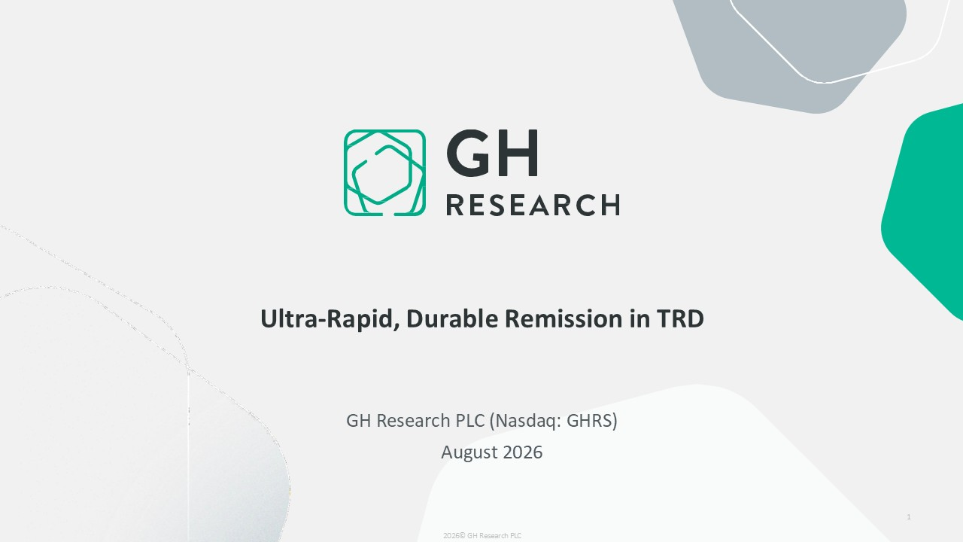
GH Research PLC (Nasdaq: GHRS) August 2026 1 2026© GH Research PLC Ultra-Rapid, Durable Remission in TRD

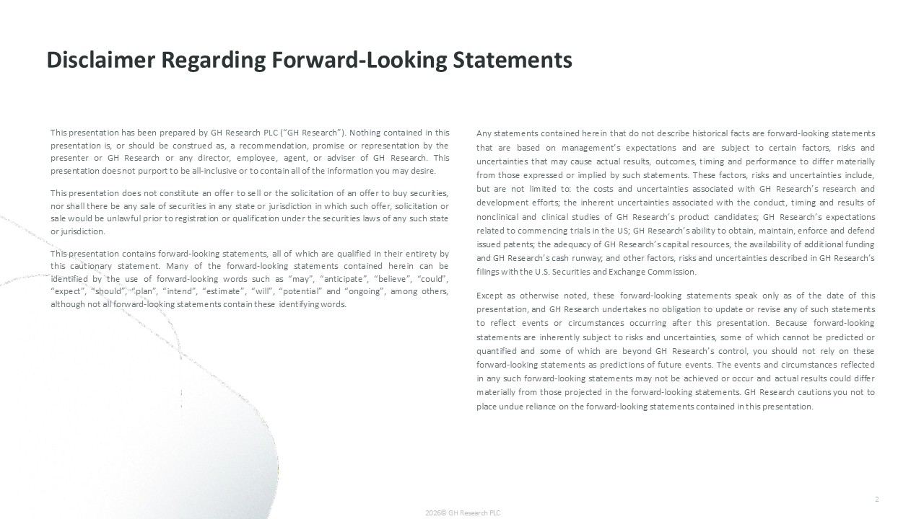
Any statements contained herein that do not describe historical facts are forward-looking statements that are based on management’s expectations and are subject to certain factors, risks and uncertainties that may cause actual results, outcomes, timing and performance to differ materially from those expressed or implied by such statements. These factors, risks and uncertainties include, but are not limited to: the costs and uncertainties associated with GH Research’s research and development efforts; the inherent uncertainties associated with the conduct, timing and results of nonclinical and clinical studies of GH Research’s product candidates; GH Research’s expectations related to commencing trials in the US; GH Research’s ability to obtain, maintain, enforce and defend issued patents; the adequacy of GH Research’s capital resources, the availability of additional funding and GH Research’s cash runway; and other factors, risks and uncertainties described in GH Research’s filings with the U.S. Securities and Exchange Commission. Except as otherwise noted, these forward-looking statements speak only as of the date of this presentation, and GH Research undertakes no obligation to update or revise any of such statements to reflect events or circumstances occurring after this presentation. Because forward-looking statements are inherently subject to risks and uncertainties, some of which cannot be predicted or quantified and some of which are beyond GH Research’s control, you should not rely on these forward-looking statements as predictions of future events. The events and circumstances reflected in any such forward-looking statements may not be achieved or occur and actual results could differ materially from those projected in the forward-looking statements. GH Research cautions you not to place undue reliance on the forward-looking statements contained in this presentation. 2026© GH Research PLC This presentation has been prepared by GH Research PLC (“GH Research”). Nothing contained in this presentation is, or should be construed as, a recommendation, promise or representation by the presenter or GH Research or any director, employee, agent, or adviser of GH Research. This presentation does not purport to be all-inclusive or to contain all of the information you may desire. This presentation does not constitute an offer to sell or the solicitation of an offer to buy securities, nor shall there be any sale of securities in any state or jurisdiction in which such offer, solicitation or sale would be unlawful prior to registration or qualification under the securities laws of any such state or jurisdiction. This presentation contains forward-looking statements, all of which are qualified in their entirety by this cautionary statement. Many of the forward-looking statements contained herein can be identified by the use of forward-looking words such as “may”, “anticipate”, “believe”, “could”, “expect”, “should”, “plan”, “intend”, “estimate”, “will”, “potential” and “ongoing”, among others, although not all forward-looking statements contain these identifying words. Disclaimer Regarding Forward-Looking Statements 2

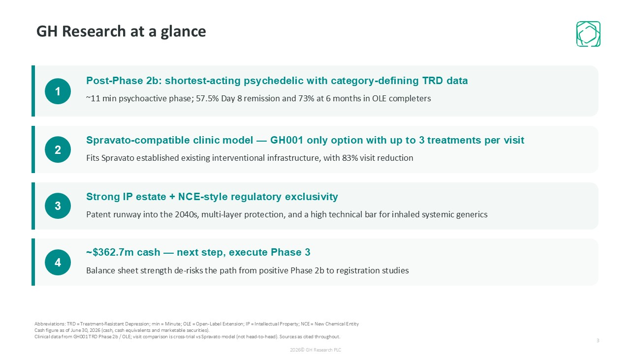
GH Research at a glance 1 Post-Phase 2b: shortest-acting psychedelic with category-defining TRD data ~11 min psychoactive phase; 57.5% Day 8 remission and 73% at 6 months in OLE completers 2 Spravato-compatible clinic model — GH001 only option with up to 3 treatments per visit Fits Spravato established existing interventional infrastructure, with 83% visit reduction 3 Strong IP estate + NCE-style regulatory exclusivity Patent runway into the 2040s, multi-layer protection, and a high technical bar for inhaled systemic generics 4 ~$362.7m cash — next step, execute Phase 3 Balance sheet strength de-risks the path from positive Phase 2b to registration studies Abbreviations: TRD = Treatment-Resistant Depression; min = Minute; OLE = Open-Label Extension; IP = Intellectual Property; NCE = New Chemical Entity Cash figure as of June 30, 2026 (cash, cash equivalents and marketable securities). Clinical data from GH001 TRD Phase 2b / OLE; visit comparison is cross-trial vs Spravato model (not head-to-head). Sources as cited throughout. 2026© GH Research PLC 3

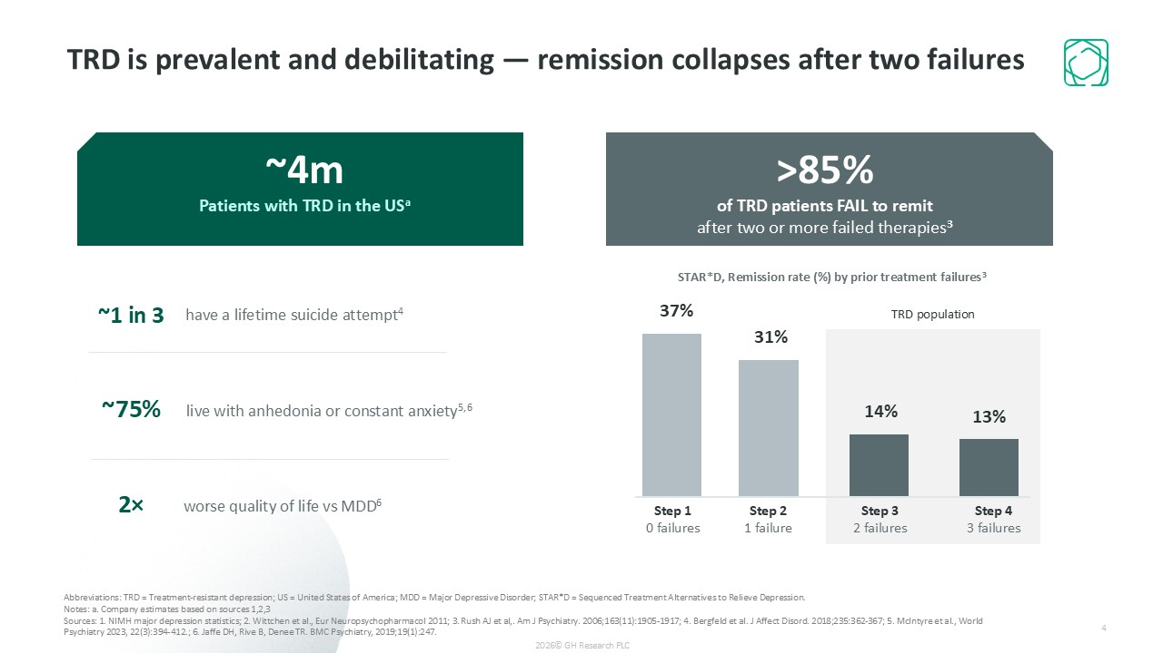
~4m Patients with TRD in the USa 37% Step 1 0 failures 31% Step 2 1 failure 14% Step 3 2 failures 13% Step 4 3 failures TRD population ~1 in 3 have a lifetime suicide attempt4 ~75% live with anhedonia or constant anxiety5,6 2× worse quality of life vs MDD6 Abbreviations: TRD = Treatment-resistant depression; US = United States of America; MDD = Major Depressive Disorder; STAR*D = Sequenced Treatment Alternatives to Relieve Depression. Notes: a. Company estimates based on sources 1,2,3 Sources: 1. NIMH major depression statistics; 2. Wittchen et al., Eur Neuropsychopharmacol 2011; 3. Rush AJ et al,. Am J Psychiatry. 2006;163(11):1905-1917; 4. Bergfeld et al. J Affect Disord. 2018;235:362-367; 5. McIntyre et al., World Psychiatry 2023, 22(3):394-412.; 6. Jaffe DH, Rive B, Denee TR. BMC Psychiatry, 2019;19(1):247. >85% of TRD patients FAIL to remit after two or more failed therapies3 STAR*D, Remission rate (%) by prior treatment failures3 TRD is prevalent and debilitating — remission collapses after two failures 2026© GH Research PLC 4

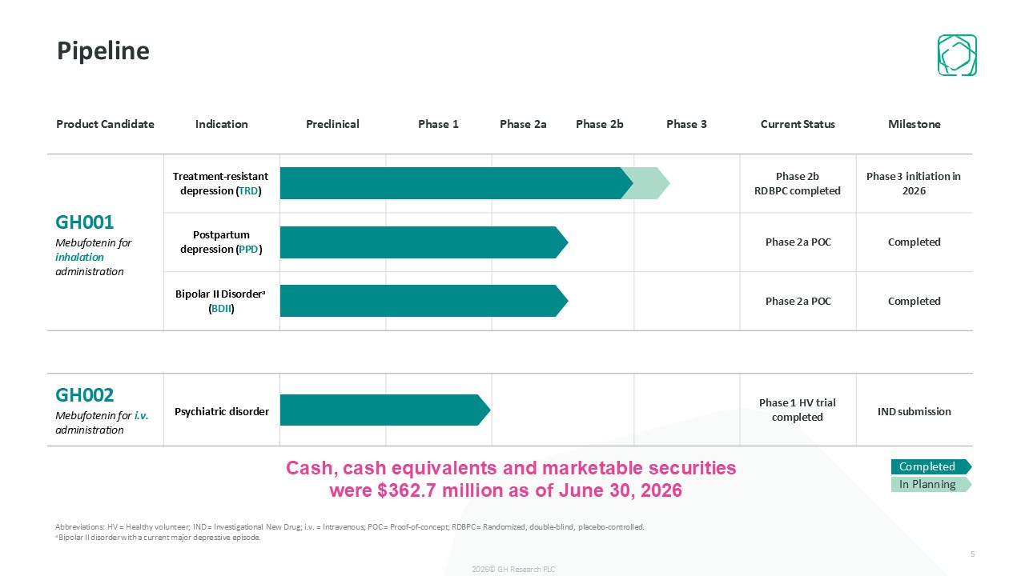
Product Candidate Indication Preclinical Phase 1 Phase 2a Phase 2b Phase 3 Current Status Milestone GH001 Mebufotenin for inhalation administration Treatment-resistant depression (TRD) Phase 2b RDBPC completed Phase 3 initiation in 2026 Postpartum depression (PPD) Phase 2a POC Completed Bipolar II Disordera (BDII) Phase 2a POC Completed GH002 Mebufotenin for i.v. administration Psychiatric disorder Phase 1 HV trial completed IND submission Pipeline Cash, cash equivalents and marketable securities were $362.7 million as of June 30, 2026 Completed In Planning Abbreviations: HV = Healthy volunteer; IND = Investigational New Drug; i.v. = Intravenous; POC = Proof-of-concept; RDBPC = Randomized, double-blind, placebo-controlled. aBipolar II disorder with a current major depressive episode. 2026© GH Research PLC 5

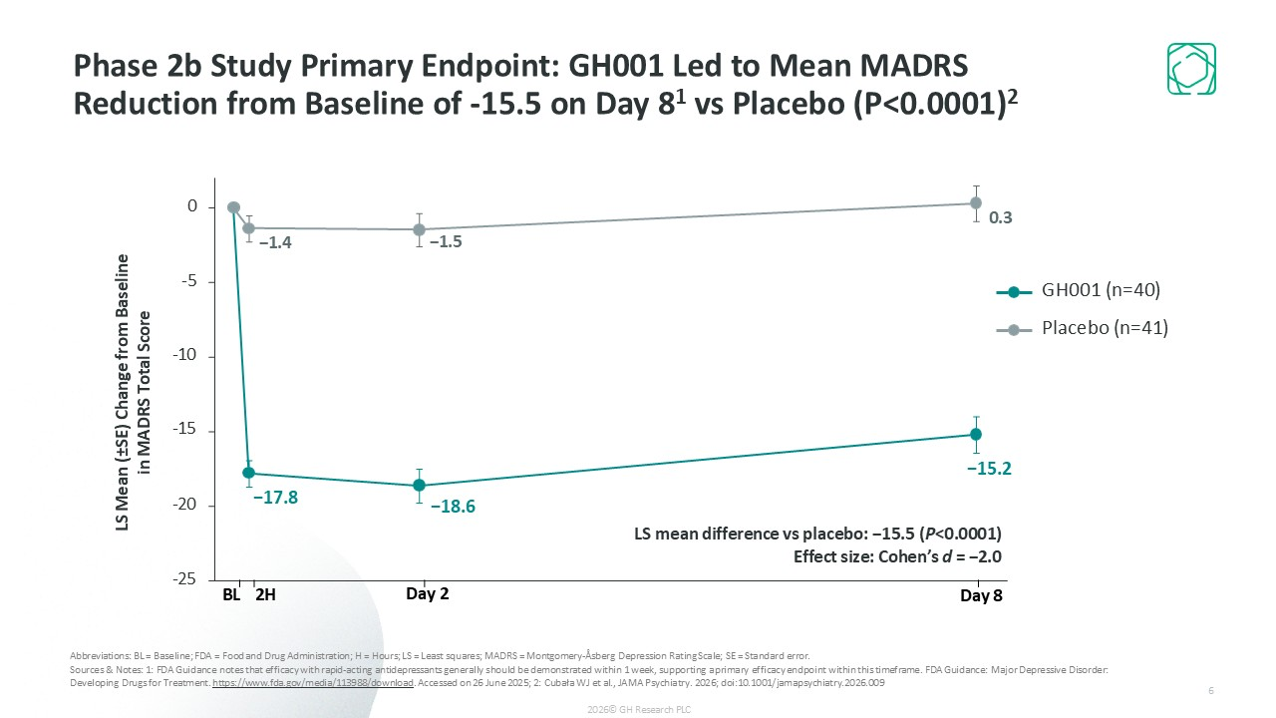
Abbreviations: BL = Baseline; FDA = Food and Drug Administration; H = Hours; LS = Least squares; MADRS = Montgomery-Åsberg Depression Rating Scale; SE = Standard error. Sources & Notes: 1: FDA Guidance notes that efficacy with rapid-acting antidepressants generally should be demonstrated within 1 week, supporting a primary efficacy endpoint within this timeframe. FDA Guidance: Major Depressive Disorder: Developing Drugs for Treatment. https://www.fda.gov/media/113988/download. Accessed on 26 June 2025; 2: Cubała WJ et al., JAMA Psychiatry. 2026; doi:10.1001/jamapsychiatry.2026.009 −17.8 −18.6 −15.2 −1.4 −1.5 0.3 -25 -20 -10 -15 -5 0 LS mean difference vs placebo: −15.5 (P<0.0001) Effect size: Cohen’s d = −2.0 LS Mean (±SE) Change from Baseline in MADRS Total Score BL 2H Day 2 Day 8 GH001 (n=40) Placebo (n=41) Phase 2b Study Primary Endpoint: GH001 Led to Mean MADRS Reduction from Baseline of -15.5 on Day 81 vs Placebo (P<0.0001)2 2026© GH Research PLC 6

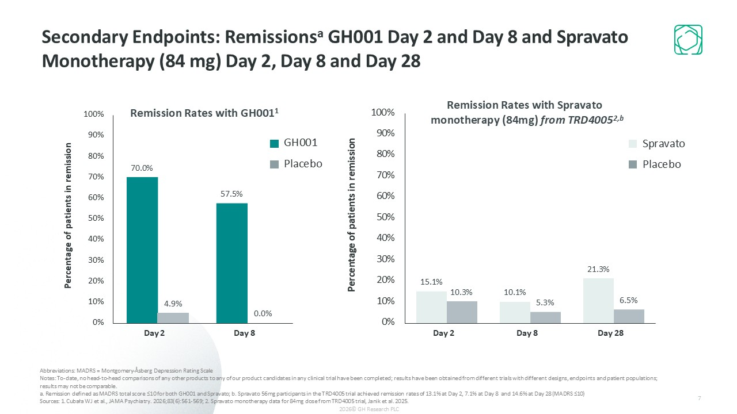
70.0% 57.5% 4.9% 0.0% 0% 10% 20% 30% 40% 50% 60% 70% 80% 90% 100% Percentage of patients in remission 15.1% 10.1% 21.3% 10.3% 5.3% 6.5% 0% 10% 20% 30% 40% 50% 60% 70% 80% 90% 100% Percentage of patients in remission Remission Rates with GH0011 Day 2 Day 8 Day 2 Day 8 Day 28 Remission Rates with Spravato monotherapy (84mg) from TRD40052,b Secondary Endpoints: Remissionsa GH001 Day 2 and Day 8 and Spravato Monotherapy (84 mg) Day 2, Day 8 and Day 28 GH001 Placebo Spravato Placebo Abbreviations: MADRS = Montgomery-Åsberg Depression Rating Scale Notes: To-date, no head-to-head comparisons of any other products to any of our product candidates in any clinical trial have been completed; results have been obtained from different trials with different designs, endpoints and patient populations; results may not be comparable. a. Remission defined as MADRS total score ≤10 for both GH001 and Spravato; b. Spravato 56mg participants in the TRD4005 trial achieved remission rates of 13.1% at Day 2, 7.1% at Day 8 and 14.6% at Day 28 (MADRS ≤10) Sources: 1. Cubała WJ et al., JAMA Psychiatry. 2026;83(6):561-569; 2. Spravato monotherapy data for 84mg dose from TRD4005 trial, Janik et al. 2025. 2026© GH Research PLC 7

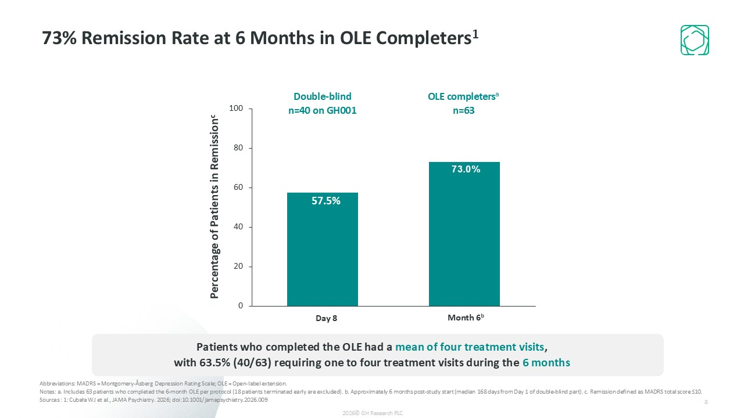
73% Remission Rate at 6 Months in OLE Completers1 Abbreviations: MADRS = Montgomery-Åsberg Depression Rating Scale; OLE = Open-label extension. Notes: a. Includes 63 patients who completed the 6-month OLE per protocol (18 patients terminated early are excluded). b. Approximately 6 months post-study start (median 168 days from Day 1 of double-blind part). c. Remission defined as MADRS total score ≤10. Sources : 1: Cubała WJ et al., JAMA Psychiatry. 2026; doi:10.1001/jamapsychiatry.2026.009 57.5% 0 20 40 60 80 100 Double-blind n=40 on GH001 OLE completersa n=63 Day 8 Percentage of Patients in Remissionc Patients who completed the OLE had a mean of four treatment visits, with 63.5% (40/63) requiring one to four treatment visits during the 6 months 73.0% Month 6ᵇ 2026© GH Research PLC 8

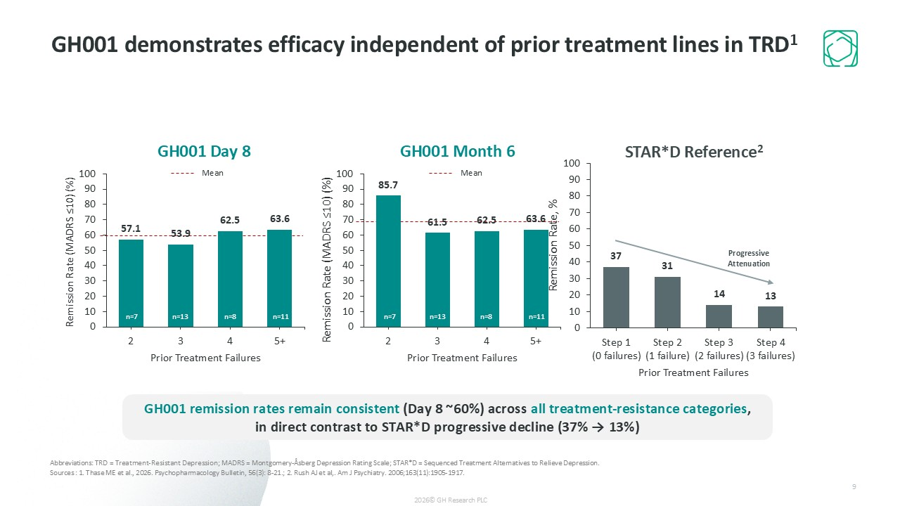
GH001 demonstrates efficacy independent of prior treatment lines in TRD1 n=7 n=13 n=8 n=11 n=7 n=13 n=8 n=11 Progressive Attenuation Mean Mean GH001 remission rates remain consistent (Day 8 ~60%) across all treatment-resistance categories, in direct contrast to STAR*D progressive decline (37% → 13%) Abbreviations: TRD = Treatment-Resistant Depression; MADRS = Montgomery-Åsberg Depression Rating Scale; STAR*D = Sequenced Treatment Alternatives to Relieve Depression. Sources : 1. Thase ME et al., 2026. Psychopharmacology Bulletin, 56(3): 8-21.; 2. Rush AJ et al,. Am J Psychiatry. 2006;163(11):1905-1917. 2026© GH Research PLC 9

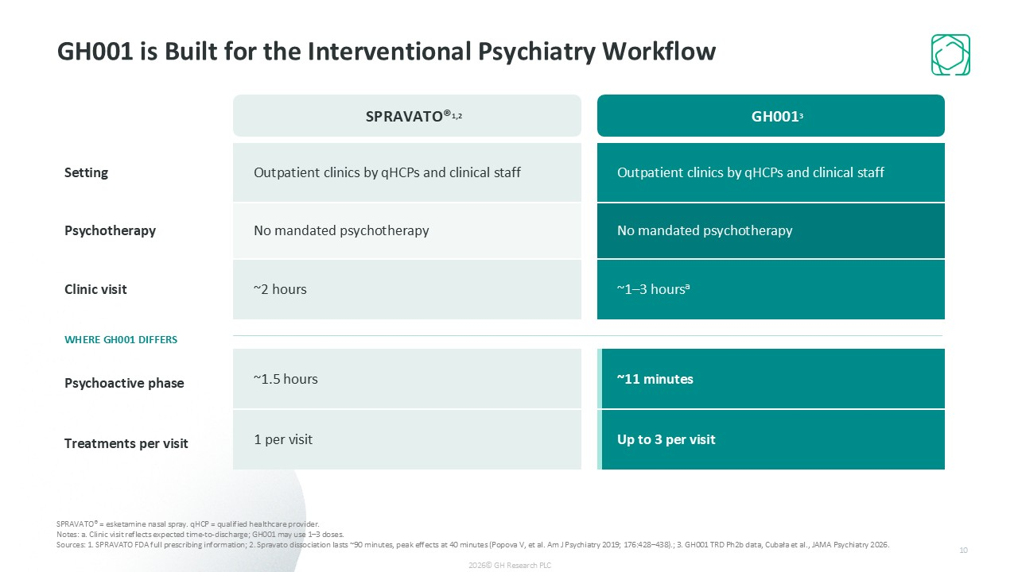
GH001 is Built for the Interventional Psychiatry Workflow SPRAVATO®1,2 GH0013 Setting Outpatient clinics by qHCPs and clinical staff Outpatient clinics by qHCPs and clinical staff Psychotherapy No mandated psychotherapy No mandated psychotherapy Psychoactive phase ~1.5 hours ~11 minutes Clinic visit ~2 hours ~1–3 hoursa Treatments per visit 1 per visit Up to 3 per visit SPRAVATO® = esketamine nasal spray. qHCP = qualified healthcare provider. Notes: a. Clinic visit reflects expected time-to-discharge; GH001 may use 1–3 doses. Sources: 1. SPRAVATO FDA full prescribing information; 2. Spravato dissociation lasts ~90 minutes, peak effects at 40 minutes (Popova V, et al. Am J Psychiatry 2019; 176:428–438).; 3. GH001 TRD Ph2b data, Cubała et al., JAMA Psychiatry 2026. WHERE GH001 DIFFERS 2026© GH Research PLC 10

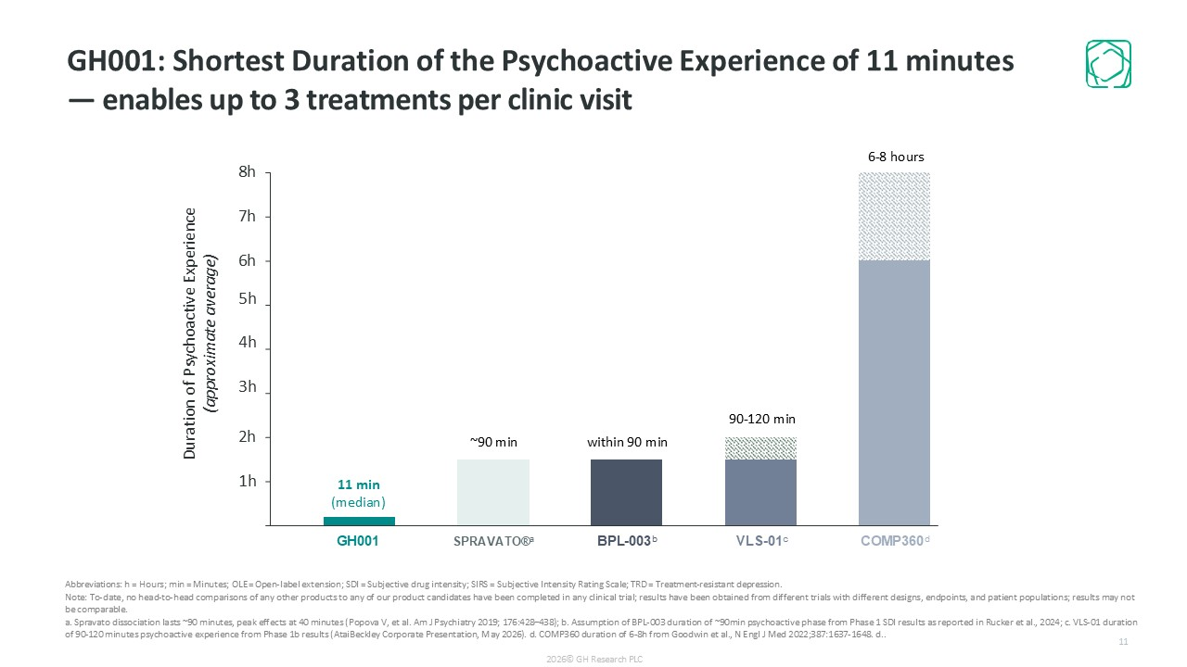
GH001: Shortest Duration of the Psychoactive Experience of 11 minutes — enables up to 3 treatments per clinic visit Abbreviations: h = Hours; min = Minutes; OLE = Open-label extension; SDI = Subjective drug intensity; SIRS = Subjective Intensity Rating Scale; TRD = Treatment-resistant depression. Note: To-date, no head-to-head comparisons of any other products to any of our product candidates have been completed in any clinical trial; results have been obtained from different trials with different designs, endpoints, and patient populations; results may not be comparable. a. Spravato dissociation lasts ~90 minutes, peak effects at 40 minutes (Popova V, et al. Am J Psychiatry 2019; 176:428–438); b. Assumption of BPL-003 duration of ~90min psychoactive phase from Phase 1 SDI results as reported in Rucker et al., 2024; c. VLS-01 duration of 90-120 minutes psychoactive experience from Phase 1b results (AtaiBeckley Corporate Presentation, May 2026). d. COMP360 duration of 6-8h from Goodwin et al., N Engl J Med 2022;387:1637-1648. d.. 0 2h Duration of Psychoactive Experience (approximate average) within 90 min 90-120 min 7h 6h 5h 4h 3h 6-8 hours 8h 2026© GH Research PLC 1h GH001 SPRAVATO®a BPL-003b VLS-01c COMP360d 11 min (median) ~90 min 11

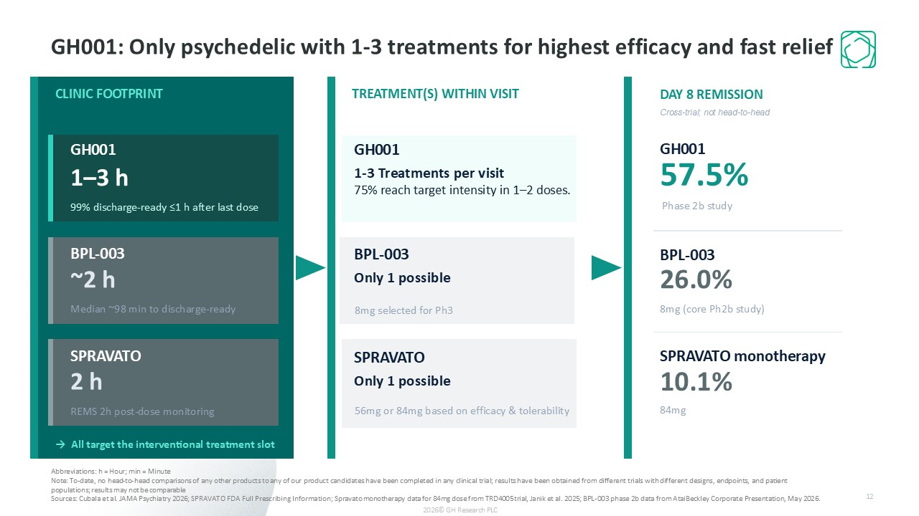
GH001: Only psychedelic with 1-3 treatments for highest efficacy and fast relief TREATMENT(S) WITHIN VISIT Not forced uptitration — stop when ready. DAY 8 REMISSION GH001 57.5% BPL-003 26.0% 8mg (core Ph2b study) Abbreviations: h = Hour; min = Minute Note: To-date, no head-to-head comparisons of any other products to any of our product candidates have been completed in any clinical trial; results have been obtained from different trials with different designs, endpoints, and patient populations; results may not be comparable Sources: Cubala et al. JAMA Psychiatry 2026; SPRAVATO FDA Full Prescribing Information; Spravato monotherapy data for 84mg dose from TRD4005 trial, Janik et al. 2025; BPL-003 phase 2b data from AtaiBeckley Corporate Presentation, May 2026. CLINIC FOOTPRINT GH001 1–3 h 99% discharge-ready ≤1 h after last dose SPRAVATO 2 h REMS 2h post-dose monitoring → All target the interventional treatment slot GH001 1-3 Treatments per visit 75% reach target intensity in 1–2 doses. SPRAVATO monotherapy 10.1% BPL-003 ~2 h Median ~98 min to discharge-ready BPL-003 Only 1 possible SPRAVATO Only 1 possible 84mg 8mg selected for Ph3 56mg or 84mg based on efficacy & tolerability Phase 2b study Cross-trial; not head-to-head 2026© GH Research PLC 12

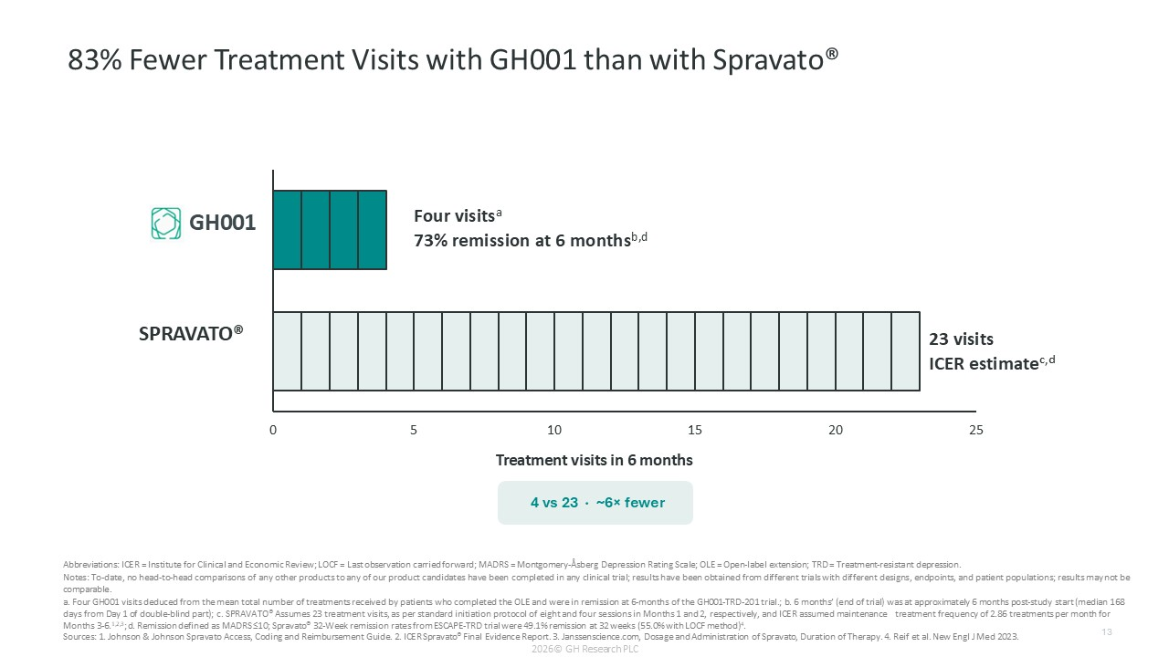
0 5 20 25 GH001 10 15 Treatment visits in 6 months 23 visits ICER estimateᶜ,ᵈ 83% Fewer Treatment Visits with GH001 than with Spravato® Four visitsa 73% remission at 6 monthsb,d SPRAVATO® 2026© GH Research PLC Abbreviations: ICER = Institute for Clinical and Economic Review; LOCF = Last observation carried forward; MADRS = Montgomery-Åsberg Depression Rating Scale; OLE = Open-label extension; TRD = Treatment-resistant depression. Notes: To-date, no head-to-head comparisons of any other products to any of our product candidates have been completed in any clinical trial; results have been obtained from different trials with different designs, endpoints, and patient populations; results may not be comparable. a. Four GH001 visits deduced from the mean total number of treatments received by patients who completed the OLE and were in remission at 6-months of the GH001-TRD-201 trial.; b. 6 months’ (end of trial) was at approximately 6 months post-study start (median 168 days from Day 1 of double-blind part); c. SPRAVATO® Assumes 23 treatment visits, as per standard initiation protocol of eight and four sessions in Months 1 and 2, respectively, and ICER assumed maintenance treatment frequency of 2.86 treatments per month for Months 3-6.1,2,3; d. Remission defined as MADRS ≤10; Spravato® 32-Week remission rates from ESCAPE-TRD trial were 49.1% remission at 32 weeks (55.0% with LOCF method)4. Sources: 1. Johnson & Johnson Spravato Access, Coding and Reimbursement Guide. 2. ICER Spravato® Final Evidence Report. 3. Janssenscience.com, Dosage and Administration of Spravato, Duration of Therapy. 4. Reif et al. New Engl J Med 2023. 4 vs 23 · ~6× fewer 13

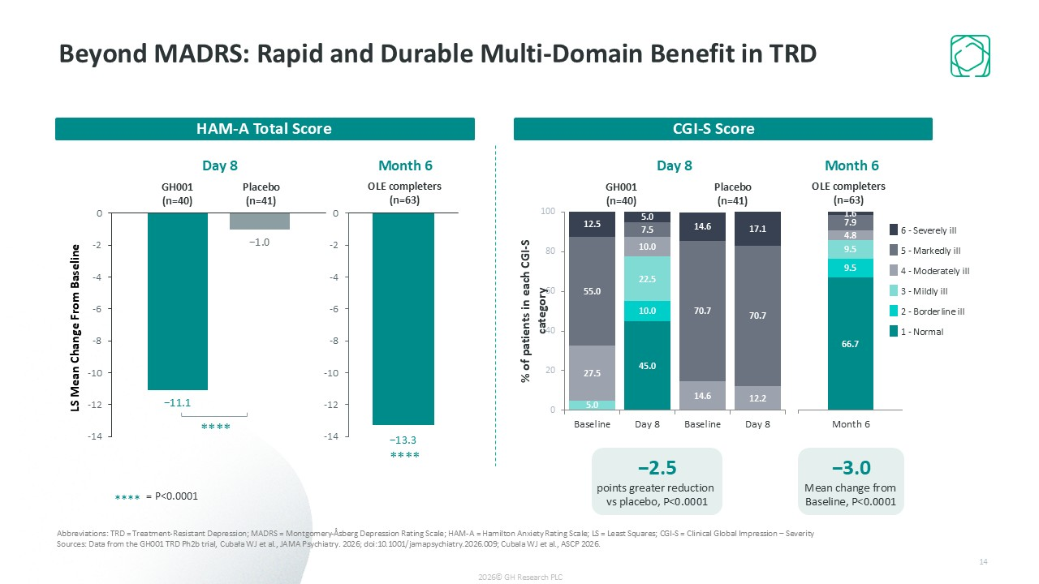
Beyond MADRS: Rapid and Durable Multi-Domain Benefit in TRD Abbreviations: TRD = Treatment-Resistant Depression; MADRS = Montgomery-Åsberg Depression Rating Scale; HAM-A = Hamilton Anxiety Rating Scale; LS = Least Squares; CGI-S = Clinical Global Impression – Severity Sources: Data from the GH001 TRD Ph2b trial, Cubała WJ et al., JAMA Psychiatry. 2026; doi:10.1001/jamapsychiatry.2026.009; Cubala WJ et al., ASCP 2026. LS Mean Change From Baseline GH001 (n=40) Placebo (n=41) CGI-S Score HAM-A Total Score −2.5 points greater reduction vs placebo, P<0.0001 6 - Severely ill 5 - Markedly ill 4 - Moderately ill 3 - Mildly ill 2 - Borderline ill 1 - Normal OLE completers (n=63) −3.0 Mean change from Baseline, P<0.0001 GH001 (n=40) Placebo (n=41) OLE completers (n=63) Day 8 Month 6 Day 8 Month 6 **** **** **** = P<0.0001 2026© GH Research PLC 14

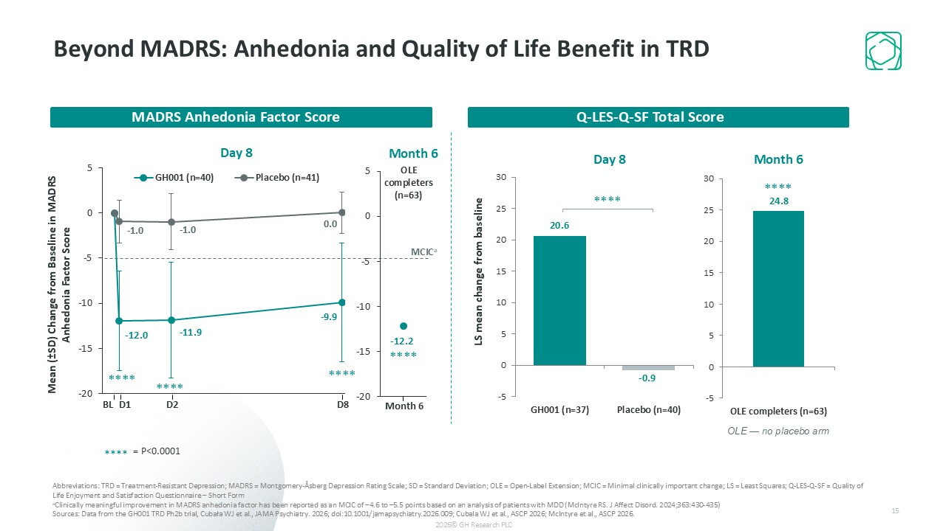
Mean (±SD) Change from Baseline in MADRS Anhedonia Factor Score BL D1 D2 D8 MCICa **** **** **** MADRS Anhedonia Factor Score Abbreviations: TRD = Treatment-Resistant Depression; MADRS = Montgomery-Åsberg Depression Rating Scale; SD = Standard Deviation; OLE = Open-Label Extension; MCIC = Minimal clinically important change; LS = Least Squares; Q-LES-Q-SF = Quality of Life Enjoyment and Satisfaction Questionnaire – Short Form aClinically meaningful improvement in MADRS anhedonia factor has been reported as an MCIC of –4.6 to –5.5 points based on an analysis of patients with MDD (McIntyre RS. J Affect Disord. 2024;363:430-435) Sources: Data from the GH001 TRD Ph2b trial, Cubała WJ et al., JAMA Psychiatry. 2026; doi:10.1001/jamapsychiatry.2026.009; Cubala WJ et al., ASCP 2026; McIntyre et al., ASCP 2026. Q-LES-Q-SF Total Score Day 8 Month 6 Month 6 **** OLE completers (n=63) Day 8 Month 6 **** **** **** = P<0.0001 OLE — no placebo arm 2026© GH Research PLC 15 Beyond MADRS: Anhedonia and Quality of Life Benefit in TRD

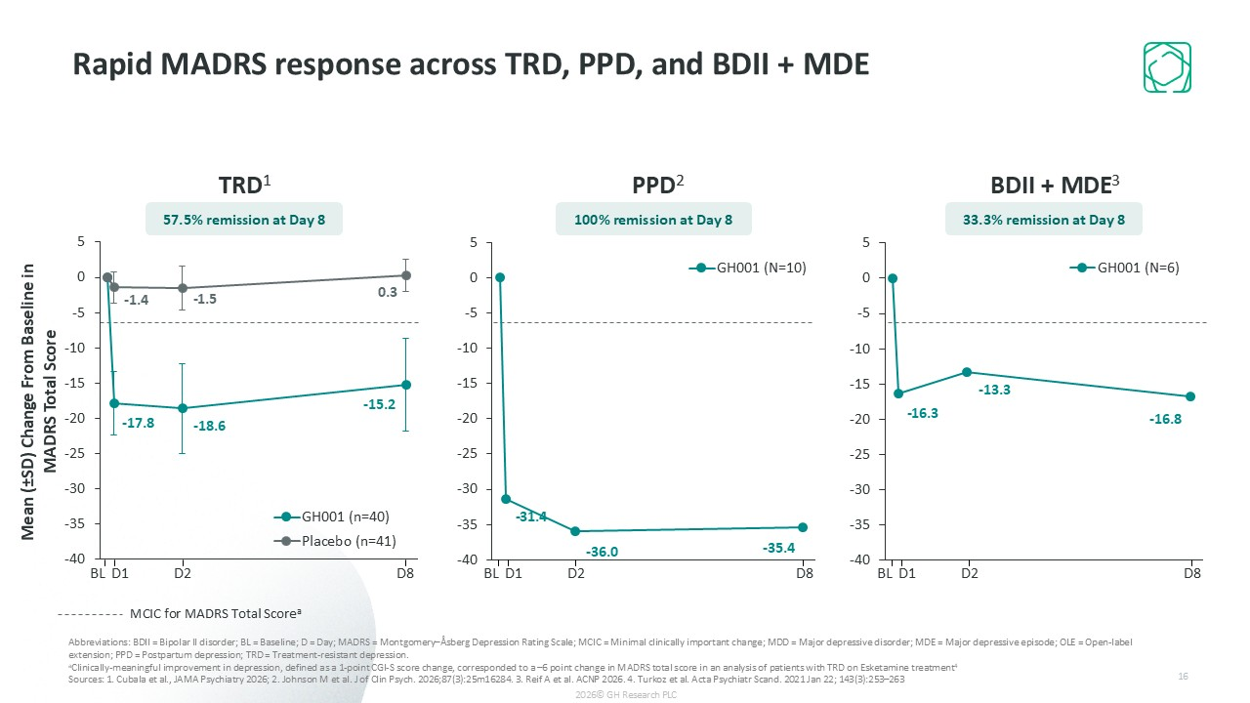
Rapid MADRS response across TRD, PPD, and BDII + MDE Abbreviations: BDII = Bipolar II disorder; BL = Baseline; D = Day; MADRS = Montgomery–Åsberg Depression Rating Scale; MCIC = Minimal clinically important change; MDD = Major depressive disorder; MDE = Major depressive episode; OLE = Open-label extension; PPD = Postpartum depression; TRD = Treatment-resistant depression. aClinically-meaningful improvement in depression, defined as a 1-point CGI-S score change, corresponded to a –6 point change in MADRS total score in an analysis of patients with TRD on Esketamine treatment4 Sources: 1. Cubala et al., JAMA Psychiatry 2026; 2. Johnson M et al. J of Clin Psych. 2026;87(3):25m16284. 3. Reif A et al. ACNP 2026. 4. Turkoz et al. Acta Psychiatr Scand. 2021 Jan 22; 143(3):253–263 Mean (±SD) Change From Baseline in MADRS Total Score BL D1 D2 D8 BL D1 D2 D8 BL D1 D2 D8 TRD1 PPD2 BDII + MDE3 MCIC for MADRS Total Scorea 57.5% remission at Day 8 100% remission at Day 8 33.3% remission at Day 8 2026© GH Research PLC 16

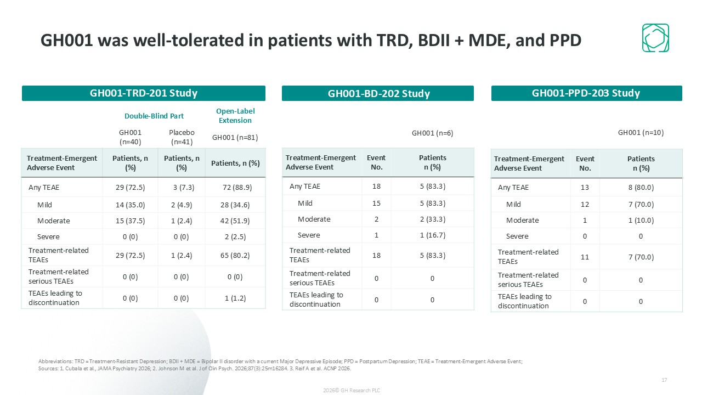
Double-Blind Part Open-Label Extension GH001 (n=40) Placebo (n=41) GH001 (n=81) Treatment-Emergent Adverse Event Patients, n (%) Patients, n (%) Patients, n (%) Any TEAE 29 (72.5) 3 (7.3) 72 (88.9) Mild 14 (35.0) 2 (4.9) 28 (34.6) Moderate 15 (37.5) 1 (2.4) 42 (51.9) Severe 0 (0) 0 (0) 2 (2.5) Treatment-related TEAEs 29 (72.5) 1 (2.4) 65 (80.2) Treatment-related serious TEAEs 0 (0) 0 (0) 0 (0) TEAEs leading to discontinuation 0 (0) 0 (0) 1 (1.2) GH001-TRD-201 Study GH001 (n=6) Treatment-Emergent Adverse Event Event No. Patients n (%) Any TEAE 18 5 (83.3) Mild 15 5 (83.3) Moderate 2 2 (33.3) Severe 1 1 (16.7) Treatment-related TEAEs 18 5 (83.3) Treatment-related serious TEAEs 0 0 TEAEs leading to discontinuation 0 0 GH001-BD-202 Study GH001-PPD-203 Study GH001 (n=10) Treatment-Emergent Adverse Event Event No. Patients n (%) Any TEAE 13 8 (80.0) Mild 12 7 (70.0) Moderate 1 1 (10.0) Severe 0 0 Treatment-related TEAEs 11 7 (70.0) Treatment-related serious TEAEs 0 0 TEAEs leading to discontinuation 0 0 GH001 was well-tolerated in patients with TRD, BDII + MDE, and PPD Abbreviations: TRD = Treatment-Resistant Depression; BDII + MDE = Bipolar II disorder with a current Major Depressive Episode; PPD = Postpartum Depression; TEAE = Treatment-Emergent Adverse Event; Sources: 1. Cubala et al., JAMA Psychiatry 2026; 2. Johnson M et al. J of Clin Psych. 2026;87(3):25m16284. 3. Reif A et al. ACNP 2026. 2026© GH Research PLC 17

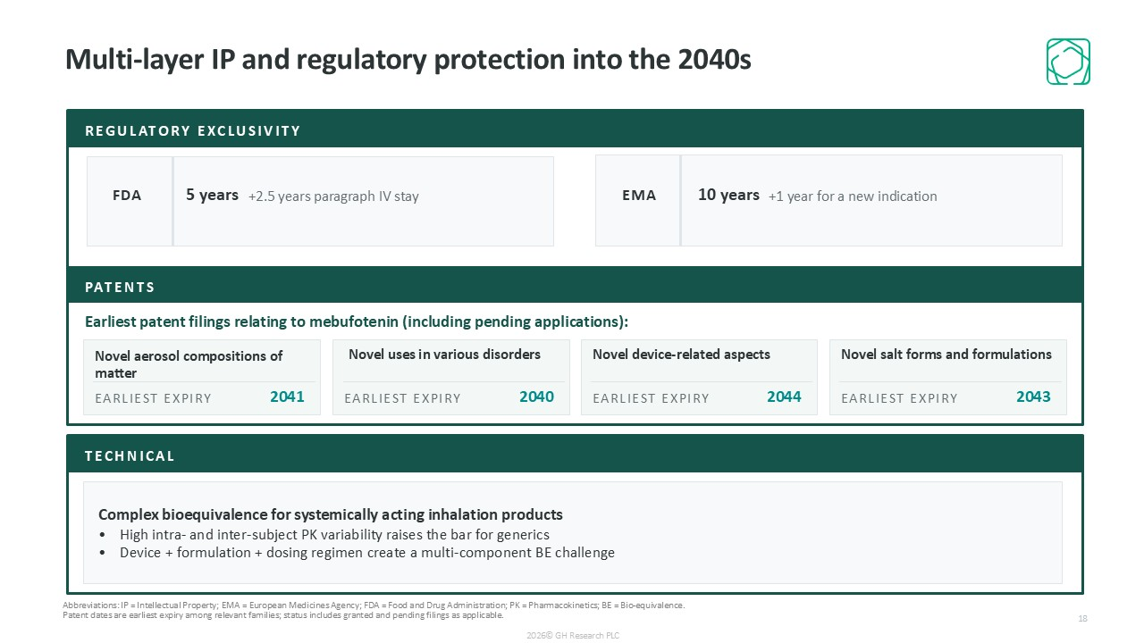
Multi-layer IP and regulatory protection into the 2040s REGULATORY EXCLUSIVITY FDA 5 years +2.5 years paragraph IV stay EMA 10 years +1 year for a new indication PATENTS Earliest patent filings relating to mebufotenin (including pending applications): Novel aerosol compositions of matter EARLIEST EXPIRY 2041 Novel uses in various disorders EARLIEST EXPIRY 2040 Novel device-related aspects EARLIEST EXPIRY 2044 Novel salt forms and formulations EARLIEST EXPIRY 2043 TECHNICAL Complex bioequivalence for systemically acting inhalation products High intra- and inter-subject PK variability raises the bar for generics Device + formulation + dosing regimen create a multi-component BE challenge Abbreviations: IP = Intellectual Property; EMA = European Medicines Agency; FDA = Food and Drug Administration; PK = Pharmacokinetics; BE = Bio-equivalence. Patent dates are earliest expiry among relevant families; status includes granted and pending filings as applicable. 2026© GH Research PLC 18

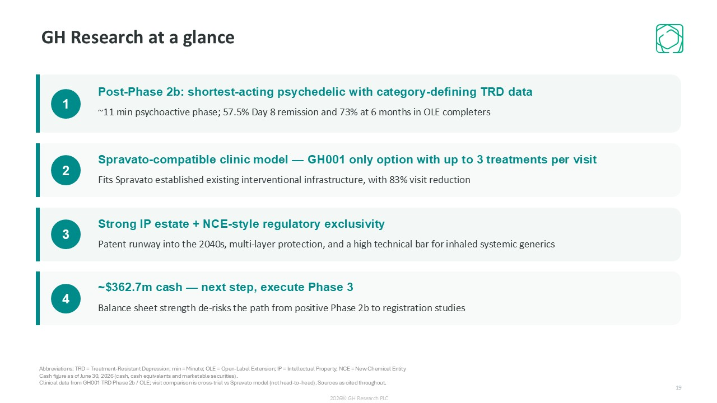
GH Research at a glance 1 Post-Phase 2b: shortest-acting psychedelic with category-defining TRD data ~11 min psychoactive phase; 57.5% Day 8 remission and 73% at 6 months in OLE completers 2 Spravato-compatible clinic model — GH001 only option with up to 3 treatments per visit Fits Spravato established existing interventional infrastructure, with 83% visit reduction 3 Strong IP estate + NCE-style regulatory exclusivity Patent runway into the 2040s, multi-layer protection, and a high technical bar for inhaled systemic generics 4 ~$362.7m cash — next step, execute Phase 3 Balance sheet strength de-risks the path from positive Phase 2b to registration studies Abbreviations: TRD = Treatment-Resistant Depression; min = Minute; OLE = Open-Label Extension; IP = Intellectual Property; NCE = New Chemical Entity Cash figure as of June 30, 2026 (cash, cash equivalents and marketable securities). Clinical data from GH001 TRD Phase 2b / OLE; visit comparison is cross-trial vs Spravato model (not head-to-head). Sources as cited throughout. 19 2026© GH Research PLC

